Evaluation of the SIRMOD model for optimum furrow irrigation performance

Abstract
This study aimed to evaluate and optimize the irrigation performance of a furrow irrigation system in the Philippines using the Surface Irrigation Simulation, Evaluation and Design (SIRMOD) model. Observed infiltration using a double ring infiltrometer and water advance for actual irrigation experiments conducted on a cornfield was used to calibrate and validate the SIRMOD model in a silty clay loam soil. Simulations showed that with appropriate cutoff time of irrigation and inflow rates, water savings from 29% to 49% depending on furrow length can be realized. This study revealed that infiltration characteristics derived from infiltration data using the double ring infiltrometer tests would suffice as input to the SIRMOD model to estimate the advance time of irrigation in an a short furrows (<100m). The SIRMOD model also showed the opportunity for water savings in furrow irrigation systems that are important inputs to irrigation development programs, subsidies, policy and decision making for farmers in the country. The same methodology can be used to optimize furrow irrigation systems in other soil conditions on farms in the Philippines and other countries.
Keywords: infiltration characteristics, water savings
1.Introduction
Water losses can get as high as 40% of the total water input in surface irrigation. More irrigation losses mean more cost of operation in furrow irrigation systems, especially for groundwater sources. High irrigation efficiency translates into lower operating costs, improved production per unit of water delivered, and improved environmental benefit and management (Irmak et al. 2011). There are no official national records of irrigated corn areas in the country since corn areas in the Philippines are dominantly rainfed. Water limitations could cause a 50% reduction on corn yield (Balderama et al. 2016a). As the climate continues to change, temperature increases and rainfall patterns are altered. Consequently, crop losses continue to incur in the rainfed corn areas. Yield gap on corn due to water limitations is significantly high that ranged from 1.7 tons/ha to 3.8 tons/ha during the 2010 dry spell as a result of simulation (Balderama et al. 2016b) using a calibrated and validated Decision Support System for Agrotechnological Transfer model. As available water resources become scarcer, more emphasis is given to efficient use of irrigation water for maximum economic return and water resources conservation (Khamssi et al. 2014). This requires appropriate methods of measuring and evaluating how efficiently water applied is used optimally to produce crop yield. Evaluation of irrigation systems would help define irrigation losses, which are major constraints in agricultural production. Optimizing irrigation performance would minimize losses that increase water application efficiency and uniformity. Also, it will lead to improved in-farm production and reduced negative impacts on water sources. Abou Kheira (2009) showed furrow irrigation with gated pipes as the best irrigation practice for salt leaching that would also give high water use efficiency. Doable methods of increasing efficiency in corn farms are through the optimized furrow design and irrigation parameters. Many surface irrigation systems are ineffective and inefficient. This can be caused by physical constraints (e.g., steep land slopes, shallow soils, poor water supplies, etc.), by poor design and layout, or by improper operation and management (Clemmens 2007). Furrow irrigation is one of the inexpensive and probably low-technique methods of surface irrigation. This traditional method generally requires higher labor and fuel consumption. It also has lower water use efficiencies and sometimes causes erosion. However, with the right intervention in furrow design and irrigation management, it could also yield high irrigation efficiency and consequently reduce loss and cost of operation.
Surface irrigation models have been helpful research tools that offer fast and reliable computations of soil-water processes to improve irrigation management, design, and operations. One of which is the Surface Irrigation Simulation, Evaluation and Design (SIRMOD) model. The SIRMOD model simulates the vertical and lateral movement of water in the soil. It uses the modified Kostiakov-Lewis model for simulating infiltration and the Saint-Venant Equations for the hydraulics of surface irrigation. It can estimate the time of advance, depth of infiltration and irrigation performance from various fields and irrigation input parameters. These include infiltration characteristics, field and furrow geometry. It also has different irrigation simulation options to choose from. The SIRMOD presents a simplified field design module and a ‘‘two-point’’ solution for the calculation of the infiltration parameters from the irrigation advance data. Calibration of infiltration characteristics in the model has been done using the two-point method which uses observed data on advance time of irrigation (Ismail & Depeweg 2005; Smith et al. 2005). The two-point method is based on the advance time of irrigation needed to reach half of the furrow length. The “two-point” method in the SIRMOD model was developed for long furrows (>300m) (Elliott & Walker 1982). However, (Ismail & Depeweg 2005) found in their study that it can also adequately simulate block-ended continuous and surge flow irrigation in short furrows (<100m). The present study attempts to investigate the appropriateness of the observed infiltration data from a double ring infiltrometer test to calibrate the Kostiakov-Lewis equation for simulating infiltration in short open-ended furrows under the local soil conditions in the study area.
Researchers have proven the applicability of the SIRMOD model for evaluating and improving irrigation efficiencies in surface irrigation systems through irrigation design and management. It has been widely used in Australia for surface irrigation applications (Clark et al. 2009; Smith et al. 2005). (Khasraghi et al. 2015) used SIRMOD for open- and closed-end border irrigation systems in Utah, USA and found that the model performed better in predicting recession times in open-ended border irrigation systems. (Mehana et al. 2009) studied the predictive ability of SIRMOD for clay loam soils in Egypt and found that it has adequately described the advance and recession times of irrigation as well as the infiltrated depth. The SIRMOD model was also found to accurately predict advance time from continuous and surge irrigation in Cuba (Rodríguez et al. 2004). (Wu et al. 2017) successfully calibrated SIRMOD model to evaluate and optimize irrigation distribution uniformity in alternate and conventional furrow irrigation in China. As of this date, there are no published studies on evaluation of the SIRMOD model for optimization of furrow irrigation systems in the Philippines. This study can serve as an input to the development of irrigation protocols on furrow irrigation cornfields in the country. It will serve as a baseline for policy and decision makers to support the improvement and sustainability of corn production. This study aimed to evaluate and optimize the irrigation performance of a furrow irrigation system in the Philippines using the Surface Irrigation Simulation, Evaluation and Design (SIRMOD) model

2.Materials and Methods
2.1The Study Site
The study was conducted in the Cagayan Valley Research Center, Isabela, Philippines geographically located at 17°7”52.56’ North and 121°52”30.54’ East at an elevation of 53 meters above mean sea level. Average historical weather data of 25 years (1988 to 2013) showed that the hottest month can be observed in June with an extreme value of 35.64 °C and the coldest is January with a minimum value of 19.88 °C. Rainy season starts in the month of May and ends in December. Annual average historical rainfall amounts to 2176 mm. Dependable rainfall during dry years is highest in the months of November with 237 mm and lowest in the months of March with 42 mm. Annual dependable rainfall during dry year’s amounts to 1618 mm. Corn is a cash crop in the region. It requires 800 mm of water from planting to maturity. Planting of this crop in the area usually takes place in the months of January. Its maturity occurs at 120 days after planting. Evapotranspiration is high in the months of May with 168 mm and lowest in the months of January with 73 mm. Due to the deficit between dependable rainfall and evapotranspiration, irrigation is needed starting in the month of January until July, when evapotranspiration is higher than the dependable rainfall. From the Bureau of Soils and Water Management laboratory analysis, silty clay loam is the type of soil in the area having a field capacity of 0.37 m³ water/m³ of soil and permanent wilting point of 0.24 m³ water/m³ of soil.
2.2 The SIRMOD model
The SIRMOD model uses three approaches, viz., the full hydrodynamic (HD), zero-inertia (ZI) and kinematic-wave (KW) to simulate the hydraulics of surface irrigation (border, furrow, and basin) on the field scale and helps in the evaluation of alternative field layouts, i.e. field length, slope, and management practices like water application rates and cutoff times (Walker 1998). (Moradzadeh et al. 2013) proved that the three irrigation models in SIRMOD can adequately predict water advance and recessions in furrow irrigation designs in Iran and concluded that the hydrodynamic and zero inertia models are better than the kinematic wave model. Similarly, (Valipour 2012) compared the 3 available irrigation hydraulic models and found that all of these models are capable of representing surface irrigation processes in many situations, however, mentioned the power of hydrodynamic and zero inertia models in the simulation process. The hydrodynamic model is the most complex but most accurate numerical simulation model (Khasraghi et al. 2015). Hence, the full hydraulic model was chosen for this study. This model is based on the governing equations of the Saint-Venant equations;
$$\frac{∂y}{∂t}+\frac{∂q}{∂x}+\frac{∂z}{∂t}=0$$
$$\frac{∂q}{∂x}+\frac{2q∂q}{y∂x}+gy\frac{∂y}{∂x}=gy\left(S_{o}-S_{f}\right)$$
where y (m) is the depth of flow, q (m3/s) is the discharge per unit width, z (m³/m) is the infiltrated volume per unit length, g (m²/s is the acceleration due to gravity, $S_{o}$ (m/m) is the field slope and $S_{f}$ is the (m/m) energy gradient.
The modified Kostiakov-Lewis equation (Mezencev 1948) is used in approximating infiltration depth. Its more general infiltration function is the extended form as follows:
$$Z=k t^{a}+ f_{o} t$$
in which fo is the long term steady, or 'basic' infiltration rate in units of volume per unit length per unit time and width. The SIRMOD software allows the user to specify furrow, border, or basin configurations with free-draining or blocked downstream boundary conditions under continuous or surged flow regimes and cutback options. The input data requirements for the simulation component include the field length, slope, infiltration characteristics, and advance data, target application depth, water application rate, Manning’s resistance, and furrow geometry.
2.3 Data collection for model set-up, calibration, and validation
To calibrate and validate the SIRMOD model, double ring infiltrometer test and irrigation experiment were conducted. Prior to the irrigation experiment, infiltrometer test using a double ring infiltrometer was conducted at the middle of the field. Since the field is homogenous, one infiltrometer test was enough to represent the infiltration characteristics of the soil. The infiltrometer test result was used to determine the calibrated values of k, a and f_{o} for the infiltration model in the area. Since the furrows are short (<100m), the infiltration model derived based on the infiltrometer test is considered adequate. The simulated infiltration rate using the modified Kostiakov-Lewis equation were compared to the actual observed infiltration rate in the field to determine how well the equation fits in the area’s local soil conditions. The coefficient of determination and t-test’s p-value were used as tests of goodness of fit between actual and simulated data both for calibration and validation processes. The coefficient of determination (R²) describes the degree collinearity between simulated and measured data. It describes the proportion of the variance in measured data explained by the model. R² ranges from 0 to 1, with higher values indicating less error variance, and typically values greater than 0.5 are considered acceptable (Santhi et al. 2002; Van Liew et al. 2003). Although R² has been widely used for model evaluation, these statistics are oversensitive to high extreme values and insensitive to additive and proportional differences between model predictions and measured data (Legates & Mccabe 1999). Thus, samples t-test procedure was used to statistically compare evaluation variables. The test computes the differences between values of the two variables for each data set and tests whether the average differs from zero. If the p-value associated with t exceeds 0.05, no signiﬁcant differences can be established between observed and simulated data. Upon successfully calibrating the infiltration equation, it was used as input to the SIRMOD model.
Actual conditions and irrigation management of furrow irrigation system in the study area were inputted in the model. The field slope along the furrow is 1%. Data measured during the experiment include the field topography and geometry, inflow and outflow rates, time of advance and infiltration rates. A profilometer was utilized to measure the furrow cross-sectional area. Furrow cross-sectional area was found to have an average value of 480.25 square centimeters. Irrigation requirement is equivalent to the infiltration requirement (Z_{req}). Soil moisture meter was used to determine the current soil moisture in the area which is then used to compute for the infiltration requirement. Furrow lengths commonly used in the study area are 50, 75 and 100 meters. These lengths were evaluated with varying inflow rates, 4.2 lps, 4.5 lps, and 4.7 lps. With these, there were nine irrigation events undertaken. During the irrigation, inflow at the head was observed periodically using a Parshall flume. Also, the time of advance was observed as the water reached the end of the furrow. The recorded time of advance was used to validate the performance of the SIRMOD model. It was compared to the SIRMOD simulated time of advance. The model was simulated under furrow irrigation field system, and free draining downstream boundary. Inflow controls included simulation shutoff control by the target application, Z_{req}, inflow regime control include a continuous flow of furrow irrigation and hydrodynamic type of simulation model. The target application depth was the requirement of the corn crops by the time of application, which was 30-cm.
2.4Evaluation of current furrow irrigation practice
After successfully calibrating and validating the SIRMOD model for the study area, it was used to assess the overall performance efficiency of the furrow irrigation system. The indicators such as distribution uniformity, application efficiency and requirement efficiency as suggested (Walker 2003) were used. (Merriam & Keller 1978) propose that distribution uniformity be defined as the average infiltrated depth in the low quarter of the field, divided by the average infiltrated depth over the whole field. The application efficiency is the water losses from the field occur as deep percolation (depths greater than Zreq) and as field tailwater or runoff. The requirement efficiency is an indicator of how well the irrigation meets its objective of refilling the root zone. This parameter is the most directly related to the crop yield since it will reflect the degree of soil moisture stress.
2.5 Optimization of furrow irrigation design and parameters
Optimum irrigation performance is achieved when both application efficiency and distribution uniformity are high while the requirement efficiency is satisfied accordingly. The optimum target for distribution uniformity is 80% and above which is considered high and the requirement efficiency of 99% should be attained for optimum application efficiency. Optimization was undertaken using a successfully calibrated and validated SIRMOD model for the study area. Optimum cutoff time was first determined for the 4.2, 4.3 and 4.5 lps inflow rates. The shortest cutoff time with optimum irrigation performance was considered the optimum cutoff time. The optimum cutoff time for each furrow length was used to determine the optimum irrigation performance in terms of inflow rate for the 100-m, 75-m, and 50-m furrow length. The relationships of application efficiencies to cutoff time and inflow rates were established for each furrow length.
3 Results and discussions
3.1 SIRMOD model calibration and validation
Based on the infiltrometer test, the basic infiltration rate was 0.000416 m³/ min per unit width per unit length. The $a$ and $k$ parameters are empirical coefficients which were based on the first data points in the infiltrometer test. Based on the infiltrometer test result analysis, the infiltration function in the area was derived as follows,
$$Z=0.016456 t^{0.2016}+ 0.000416 t$$
Where Z is the depth of infiltration, m and t is the time of infiltration, min. Figure 1 shows the goodness of fit between actual and K-L computed infiltration rate. The K-L equation performed well in replicating the actual infiltration rate with 0.99 R² with a p-value greater than 0.05 in the t-test result. This suggests that the derived infiltration equation can be used to represent the infiltration characteristics in the area.
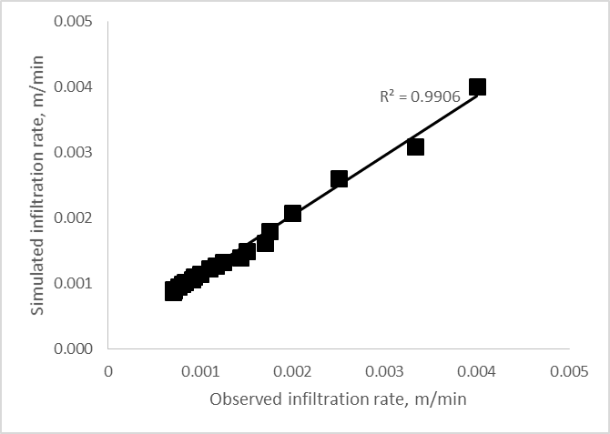
Figure 1 Comparison of simulated and actual infiltration rate in the study area
3.2 SIRMOD model validation
Figure 2 shows the goodness of fit between observed and simulated advance time. The goodness of fit between the simulated and actual time of advance is high at 99.8%. The t critical (2.12) is greater than the t-statistic (0.31) and a p-value of 0.76 (>0.05) showed that the variability between means of simulated and actual time of advance was not significant which means the validation was successful. This implies that the model accurately computed the time of advance and can be used to simulate and optimize the furrow irrigation system in the area. The advance time was carefully observed and recorded which may have contributed to high goodness of fit. This result also proved that the calibrated infiltration equation fits the actual soil characteristics in the area.
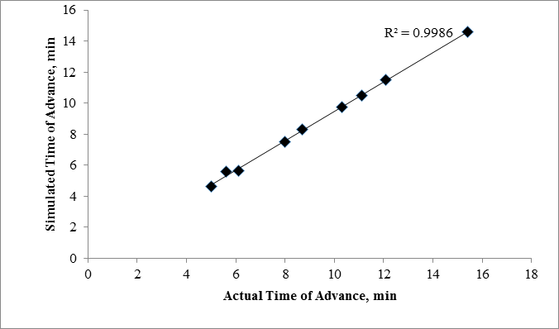
Figure 2 Actual versus simulated time of advance of the nine irrigation events in 100-m, 75-m and 50-m furrow length with 4.2, 4.5 and 4.7 lps inflow rates
3.4 Evaluation of the existing furrow irrigation practice
Since the model was successfully calibrated and validated, it was used to estimate the irrigation performance of current practice in the study area. Results showed that the application efficiency of furrow irrigation systems in the study area is relatively low which ranged from 33-50% in 100-m furrow lengths, 42-47% in 75-m furrow lengths and 37-45% in 50-m furrow lengths (Table 1). The tailwater ratios varied from 21-24% in 100-m furrow lengths, 20-31% in 75-m furrow lengths and 36-39% in 50-m furrow lengths. Deep percolation ratios ranged from 28-29%, for 100-m furrow lengths, 23-30% in 75-m furrow lengths and 18-23% in the 50-m furrow lengths. These values are lower compared to the 60% application efficiency for surface irrigation published by FAO. Therefore, there is an opportunity to optimize the furrow irrigation system in the area.

Table 1 Evaluation results for the current furrow irrigation practice in the area
Discharge level, lps | Furrow length, m | Application efficiency, % | Required Efficiency, % | Distribution Uniformity, % | Tailwater fraction, % | Deep percolation ratio, %
4.2 | 100 | 49.44 | 99.67 | 94.06 | 21.95 | 28.61
4.5 | 100 | 46.64 | 99.67 | 92.25 | 24.36 | 29
4.7 | 100 | 50.15 | 99.67 | 91.81 | 21.58 | 28.27
4.2 | 75 | 48.56 | 99.67 | 96.02 | 25.28 | 26.16
4.5 | 75 | 44.56 | 99.67 | 96.03 | 31.82 | 23.62
4.7 | 75 | 49.7 | 99.67 | 91.36 | 20.27 | 30.03
4.2 | 50 | 45.25 | 99.67 | 96.18 | 36.6 | 18.15
4.5 | 50 | 38.5 | 99.67 | 92.56 | 37.95 | 23.55
4.7 | 50 | 40.44 | 99.67 | 97.19 | 39.3 | 20.26

2.5 Optimization of Furrow Irrigation
The optimum cutoff time with almost 100% irrigation requirement satisfied and distribution uniformity of more than 80% are shown in figure 3, figure 4 and figure 5 for the 100-m, 75-m, and 50-m furrow lengths, respectively. It can be observed that the variation in inflow rates did not significantly affect the optimum cutoff time for all the furrow lengths studied. However, there were differences in the optimum performance indices, particularly on the application efficiency. All of the chosen optimum cutoff time had more than 80% distribution uniformities and almost 100% requirement efficiencies. The optimum cutoff time for the 100-m furrow length was 15 minutes for individual furrows for all the set inflow rates. For this cutoff time and furrow length, the 4.2 lps inflow rate yielded the highest application efficiency by 64%, followed by the 4.5 lps with 59% and the last was from the 4.7 lps with 57%. The same trend was observed in the 75-m furrow length. The optimum cutoff time for the 75-m furrow length was found to be 10 minutes per furrow. Similarly, the lowest inflow rate gave the highest application efficiency. The 4.2 lps inflow rate yielded an application efficiency of 67%, the 4.5 lps with 62% and the 4.7 lps with 60%. The 50-m furrow length had the same optimum cutoff time with the 75-m furrow length but had lower application efficiencies. The 4.2 lps resulted in an application efficiency of 44%, the 4.5 lps with 39% and the 4.7 lps yielded the lowest with 39%. It is notable that the set inflow rates seemed to be most appropriate for the 100-m and 75-m furrow lengths, which yielded better application efficiencies compared to the shortest furrow length. Piping systems that would provide simultaneous irrigation to individual furrows will reduce the time of irrigation for the whole field.

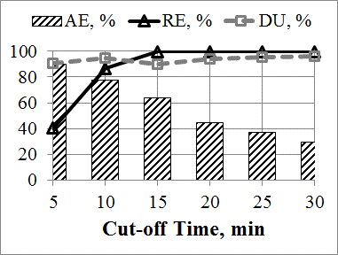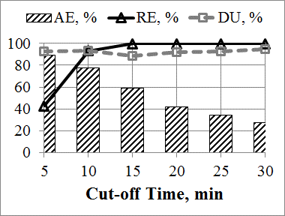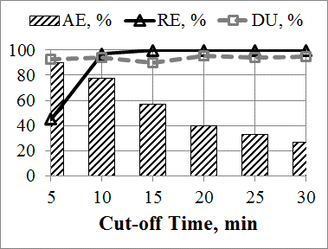
- (b) (c)
Figure 3 Sensitivity analysis on cutoff time for the (a) 4.2 lps, (b) 4.5 lps and (c) 4.7 lps in 100 meter furrow length

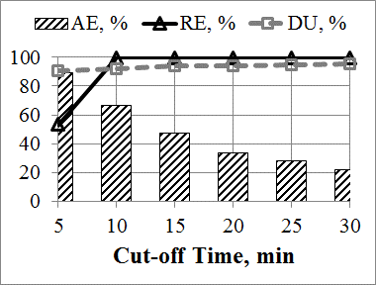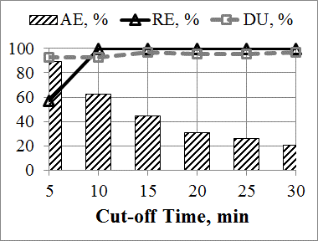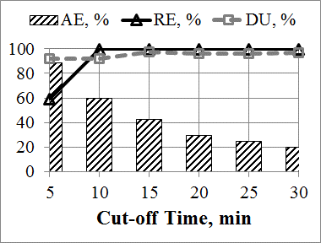
- (b) (c)
Figure 4 Sensitivity analysis on cutoff time for the (a) 4.2 lps, (b) 4.5 lps and (c) 4.7 lps in 75 meter furrow length

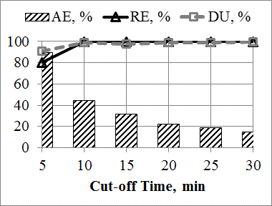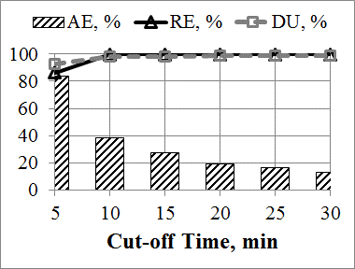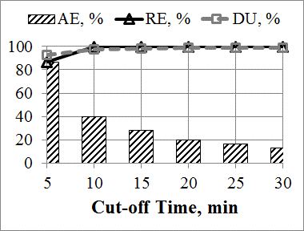
- (b) (c)
Figure 5 Sensitivity analysis on cutoff time for the (a) 4.2 lps, (b) 4.5 lps and (c) 4.7 lps in 50 meter furrow length

Using the optimum cutoff time for each furrow length , the inflow rates were further varied from 1lps to 6 lps to further investigate if there is still room for increasing the performance of irrigation in the area. It can be observed in figure 6 that the optimum inflow rate was 3.5 lps both for the 100-m and 75-m furrow lengths while 2 lps for the 50-m furrow length. Similarly, these management combinations yielded more than 80% distribution uniformities and almost 100% requirement efficiencies. However, application efficiencies varied across optimum inflow rates and furrow lengths. The 100-m furrow length can be optimized with an application efficiency of as high as 76%, while the 75-m furrow length up to 80%. Notably, the 50-m furrow length had the biggest leap with the highest application efficiency of 87%. These suggest that with the proper combination of cutoff time and inflow rates depending on the furrow length, water savings can range from 29-49% relative to the current furrow irrigation practice. The current practice of using 4.5 lps inflow rates had 47% application efficiency of the 100-m furrow length, 45% of the 75-m furrow length and 38% of the 50-m furrow length. These also imply that farmers in the area can buy lower capacity water pumps, thus lower buying cost. These results can now be used as decision support to farmers inappropriate irrigation operation and the government in providing water pump subsidies for farmers.
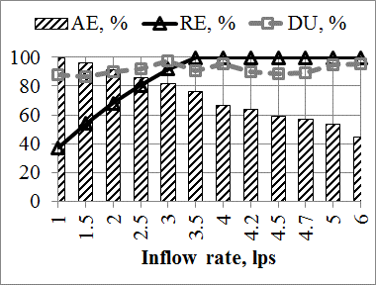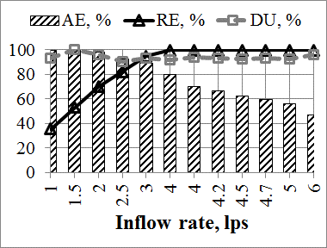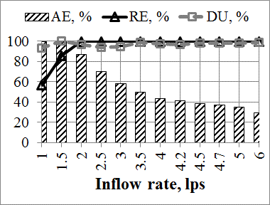
- (b) (c)
Figure 6 Optimum inflow rate for the (a) 100-m, (b) 75-m and (c) 50-m furrow lengths using the optimum cutoff time of irrigation

To further magnify the impact of irrigation management on irrigation performance, the relationship of application efficiencies to cutoff time and inflow rates were analyzed. At the cutoff time of irrigation was increased, the application efficiency decreases logarithmically for the 100-m and 75-m furrow lengths and decreases exponentially in the 50-m furrow length (fig. 7). In addition, as the inflow rate increases, the application efficiency decreases linearly both in the 100-m and 75-m furrow lengths while it decreases exponentially in the 50-m furrow length.

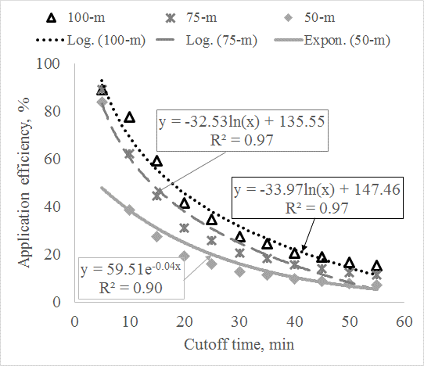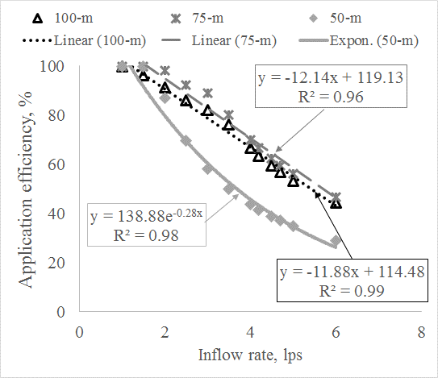
- (b)
Figure 7 Relationship of application efficiency to (a) cutoff time and (b) inflow rate for each furrow length
Discussion
The calibration of the SIRMOD model using the observed infiltration data from the double ring infiltrometer test has been proven to be adequate for simulating the advance time of irrigation in the area. This suggested that the method can be used as an alternative to the two-point method which needs an observed time of advance for calibration. However, this conclusion has been drawn from the study of short furrows (<100m). This result may be largely due to the homogenous soil and crop conditions in the area. Ismail & Depeweg (2005) also used SIRMOD in short furrows and found that the two-point method can be enough to determine the infiltration characteristics for short furrows under continuous and surge flow irrigations. This study found, and offers alternative to the two-point method, which needs actual irrigation experiments to collect irrigation advance data. The double ring infiltrometer is a simpler technique, which may need less water, time and work compared to the two-point method.

The derived infiltration equation was used in the evaluation of the current furrow irrigation practice revealed low efficiencies, which implied that appropriate irrigation management is needed. Sensitivity analyses showed higher discharge rate yields lower application efficiency and lower discharge rates yielded high application efficiencies. Low efficiency in furrows with high inflow rate was due to the high value of tailwater and deep percolation ratio. Shorter cut-off time and lower inflow rates would lead to lower fuel cost, time saving and lower operating cost of optimum application efficiency. Water savings from 29% to 49%, depending on the furrow length can be realized by using 10 to 15 minutes cutoff time and 3 to 3.5 liters per second inflow rates during irrigation operations. From the result of this study, a farmer can now base his decision on buying a pump with his existing furrow length and desired cutoff time to achieve optimum water savings and thus, lower cost of operation. Also, with a given pump discharge capacity, a farmer can now select the cutoff time that will save time of irrigation and fuel consumption that will give optimum irrigation performance. Application efficiency is adversely affected by increases in inflow rates and cutoff time, thus these variable is significant to optimize water savings in furrow irrigation and should always be considered during operations. Moreover, shortening furrows to 50 meters while using the optimum irrigation management can also be considered since they were found to have the best performance. The SIRMOD model demonstrated its usefulness in assessing furrow irrigation systems in the Philippines. It also showed the doable techniques to conserve water without reductions on the crop water requirement through improved application efficiency and sustained distribution uniformity and requirement efficiency. The same method of optimization for furrow irrigation systems using the SIRMOD model can also be employed in other soil conditions in the Philippines and other countries.

Acknowledgement
This research was financially supported by the Isabela State University, Philippines under their general appropriations act funds and technically assisted by the Central Luzon State University by providing research tools (profilometer and Parshall flumes), field assistance and guidance of Dr. Armando N. Espino through his Commission on Higher Education’s funded project. The author would also like to thank the Cagayan Valley Research Center, Department of Agriculture Regional Field Unit 2, Ilagan City Isabela for the provision of the experimental area.

Conflicts of interest
The author declares no conflicts of interest
References
Abou Kheira A.A. 2009. Comparison among different irrigation systems for deficit-irrigated corn in the Nile Valley. Agricultural Engineering International: CIGR Journal XI.
Balderama O., L. Alejo and E. Tongson. 2016a. Calibration, validation and application of CERES-Maize model for climate change impact assessment in Abuan Watershed, Isabela, Philippines. Climate, Disaster and Development Journal 2(1): 11–20.
Balderama O.F., L.S. Alejandro, O.O. Barbosa and M.B. Mata. 2016b. Assessment of potential yield and climate change sensitivity of selected dryland crops in Cagayan Valley, Philippines using simulation models. Special Issue on BIMP-EAGA Journal for Sustainable Tourism Development 5(1): 102–113.
Clark B., L. Hall, G. Davids, W. Walker and J. Eckhardt. 2009. Application of SIRMOD to evaluate potential tailwater reduction from improved irrigation management. World Environmental and Water Resources Congress 2009. American Society of Civil Engineers: Reston, VA, 1–11
Clemmens A.J. 2007. Simple approach to surface irrigation design: Theory. Land and Water 1: 1–19.
Elliott R. and W. Walker. 1982. Field evaluation of furrow irrigation and advance functions. Transactions of the ASAE 25(6): 396–400.
Irmak S., L.O. Odhiambo, W.L. Kranz and D.E. Eisenhauer. 2011. Irrigation efficiency and uniformity , and crop water use efficiency irrigation efficiency and uniformity , and crop water use efficiency. Biological Systems Engineering: Papers and Publications
Ismail S.M. and H. Depeweg. 2005. Simulation of continuous and surge flow irrigation under short field conditions. Irrigation and Drainage 54: 217–230.
Khamssi N.N., K. Ghassemi-Golezani and A. Najaphy. 2014. Canopy growth , irrigation water use efficiency and relative water content of chickpea under acclimation to gradual water deficit conditions. International Journal of Plant, Animal and Environmental Sciences 4(1): 324–331.
Khasraghi M.M., M.A.G. Sefidkouhi and M. Valipour. 2015. Simulation of open- and closed-end border irrigation systems using SIRMOD. Archives of Agronomy and Soil Science 61(7): 929–941.
Legates D.R. and G.J. Mccabe. 1999. Evaluating the use of “goodness-of-fit” measures in hydrologic and hydroclimatic model validation. Water Resources Research 35(1): 233–241.
Mehana H.M., K.F. El-Bagoury, M.M. Hussein and A.M. El-Gindy. 2009. Validation of surface irrigation model SIRMOD under clay loam soil conditions in Egypt. Misr Journal of Agricultural Engineering 26(3): 1299–1317.
Merriam J.L. and J. Keller. 1978. Farm irrigation system evaluation: A guide for management, agricultural and irrigation.
Mezencev V.J. 1948. Theory of formation of the surface runoff. Meteorologiae Hidrologia 3: 33–40.
Moradzadeh M., S. Boroomandnasab, R. Lalehzari and M. Bahrami. 2013. Performance Evaluation and Sensitivity Analysis of Various Models of SIRMOD Software in Furrow Irrigation Design. Water Engineering 6(18): 63–73.
Rodríguez J.A., A. Díaz, J.A. Reyes and R. Pujols. 2004. Comparison between surge irrigation and conventional furrow irrigation for covered black tobacco cultivation in a Ferralsol soil. Spanish Journal of Agricultural Research 2(3): 445–458.
Santhi C., J.G. Arnold, J.R. Williams, W. a. Dugas, R. Srinivasan and L.M. Hauck. 2002. Validation of the SWAT model on a large river basin with point and nonpoint sources. Journal of the American Water Resources Association (JAWRA) 37(5): 1169–1188.
Smith R.J., S.R. Raine and J. Minkevich. 2005. Irrigation application efficiency and deep drainage potential under surface irrigated cotton. Agricultural Water Management 71: 117–130.
Valipour M. 2012. Comparison of surface irrigation simulation models: full hydrodynamic, zero inertia, kinematic wave. Journal of Agricultural Science 4(12).
Van Liew M.W., J.G. Arnold and J.D. Garbrecht. 2003. Hydrologic simulation on agricultural watersheds: Choosing between two models. Trans. ASAE 46(6): 1539–1551.
Walker W. 1998. SIRMOD - Surface Irrigation Modeling Software.
Walker W.R. 2003. SIRMOD III Surface Irrigation Simulation, Evaluation and Design Guide and Technical Documentation.
Wu D., J. Xue, X. Bo, W. Meng, Y. Wu and T. Du. 2017. Simulation of irrigation uniformity and optimization of irrigation technical parameters based on the SIRMOD model under alternate furrow irrigation. Irrigation and Drainage 66(4): 478–491.

