Temporal Crop Coefficients and Water Productivity of Lettuce (Lactuca sativa L.) Hydroponics In Planthouse
Riani Muharomah^{1*}, Budi Indra Setiawan², Mohammad Yanuar Jarwadi Purwanto², Liyantono³
¹Postgraduate Program of Agricultural Engineering Science, Bogor Agricultural University, Indonesia
²Department of Civil and Environmental Engineering, Bogor Agricultural University, Indonesia
²Department of Mechanical and Biosystem Engineering, Bogor Agricultural University, Indonesia
*Corresponding author: riani.muharomah@gmail.com

ABSTRACT
Almost all countries in the world have used lettuce hydroponic cultivation in planthouses because it is appropriate for plant growth and production. The microclimate inside planthouse is an environmental factor that affects plant growth and development. Vegetables planted in the planthouse have a great deal of water requirement. Selecting a method with a more accurate estimation of crop evapotranspiration is a critical factor for efficient water management. In this research, the climates that are affecting the lettuce evapotranspiration with modification of floating hydroponic technique inside the planthouse were investigated. The objectives of this research are to figure out the microclimate, the appropriate model of the potential evapotranspiration, and the temporal crop coefficients and water productivity of lettuce grown using a floating hydroponic technique in a planthouse. Experimental planthouse uses 90% transparency of polycarbonate roofs and net walls, with the dimension is 9 x 3 x 4 m. Primary data collected in the form of water level, and climate data for both inside and outside the planthouse. ETp value was estimated using seven models of potential evapotranspiration and among those models, the most appropriate model is determined. The climate inside the planthouse was significantly different than that in the outside. In which during 40 days of lettuce cultivation, solar radiation and relative humidity in the inside were lower than in the outside, but the temperature inside was higher than the outside. Potential evapotranspiration inside the planthouse can be estimated precisely by Hargreaves model. Crop coefficient (Kc) changed with time forming a parabolic equation started at 0.7 then decreased to reach 0.4 then increase to 1.4. Lettuce productivity was 1114.6 g/m² having water productivity 29.58 g/l which was linearly related to the consumptive use of water by the plant.
Keyword: Lettuce hydroponics, microclimate, evapotranspiration, crop coefficient, water productivity.

INTRODUCTION
Until now, almost all countries in the world used lettuce hydroponic cultivation in planthouses especially at the middle altitude because it is appropriate for plant growth and production. Planthouse can enable control of meteorological conditions that significantly affect plant growth and development (Haraguchi et al. 2005). Plant growth is influenced by weather and climate. Climate is one of the factors that affect productivity and can optimize resource use in production systems (Koesmaryono et al. 1997). In plant growth, almost all elements of weather significantly influence it, while the factors that most influence plant growth and development are air temperature and day length. The purpose of planthouses use is to create a favourable microclimate for plant growth when climate conditions are not conducive. Suhardiyanto et al. (2009) argue that the use of planthouses in crop cultivation is one way to provide an environment that is closer to the optimum conditions for plant growth. Furthermore, it is stated that the use of planthouses allows environmental modification that is not suitable for plant growth to be closer to the optimum conditions for plant growth. Planthouses is a building that serves to protect plants from various kinds of weather disturbances such as rain, wind, and the intensity of high solar radiation and protect plants from pest attacks. In general, planthouses are needed for plants that have significant economic value such as various types of flower plants (including roses, carnations, gladiolus, orchids, and chrysanthemums), vegetable plants (including tomatoes, peas, broccoli, mustard greens, and paprika), fruit plants (including melons, grapes, and watermelons). Besides, planthouses in Indonesia are very suitable for export commodity crops that require good quality and uniform size.
The microclimate inside planthouse is an environmental factor that affects plant growth and development. Closed and semi-enclosed planthouses aim to get excessive heat to meet heat requirements while maintaining the best possible environmental conditions for plant growth (Boulard et al. 2017). In cultivation using planthouses, solar energy stimulates plant photosynthesis (Mobtaker et al. 2016). The solar radiation was the most critical factor that influences ET among environmental parameters (Zhang et al. 2010). The effect of radiation changes on the micro-greenhouse climate is significant because about 40% of incoming solar radiation is absorbed by crop cover (Boulard et al. 2017). Air temperature affects plants through metabolic processes in the body of the plant, which are reflected in various characters such as growth rates, seed dormancy and buds, germination, flowering, and maturation of plant organ. The response of plants to temperature varies depending on the type of plant, variety, and stage of plant growth. Therefore, it is necessary for farmers to use water with high efficiency. Vegetables planted in the planthouse have a great deal of water requirement, and irrigation is the only water source for plant growth owing to the plastic film roof avoiding from the rainfall.
Selecting a method with a more accurate estimation of crop evapotranspiration is the critical factor for efficient water management (Tyagi et al. 2000); (Mao et al. 2003) (Zhang et al. 2004). Water management and crop yields can be improved through increased use of reliable methods for estimating crop evapotranspiration (Hargreaves et al. 2003). The study of crop evapotranspiration is a crucial issue to understand and improve the environments of plants in both open field and planthouse cultivation (Takakura et al. 2009). Evapotranspiration (ET) is the total loss of water to the atmosphere through evaporation and transpiration (the loss of water from the plant). Evaporation and transpiration, and there is no easy way of distinguishing between the two processes. The accurate estimation of water loss by ET is significant for assessing water availability and requirements of the plant. The Penman-Monteith reference evapotranspiration equation cannot be used directly under solar planthouse microclimatic conditions because of the neglect of aerodynamics (the wind speed in solar planthouse approximately equal to zero).
In this research, the climates that are affecting the lettuce evapotranspiration with modification of floating hydroponic technique inside the planthouse were investigated. The evapotranspiration rate inside the planthouse systems is dominated by transpiration from the plant. Crop transpiration not only affected by climatic parameters (temperature, light intensity, wind, humidity) but also from another setting, such as crop growth stage. The evaporation value is minimal due to very small, or no open area exists. The evapotranspiration rate is influenced by the amount of solar radiation and the temperature outside and inside the planthouse. The existing models for estimating potential evapotranspiration only appropriate to outside the planthouse because the microclimates inside the planthouse are different as those at the outside, while for actual lettuce evapotranspiration with modification floating hydroponic technique inside a planthouse is known through the decrease in water level. Whereby the effect of the climate on the decline in water level is given by the potential evapotranspiration and the impact of the crop by the crop coefficient (Kc), the consumptive water uses also influence the yield and water productivity so that the objectives of this research are to figure out the microclimate, the appropriate model of the potential evapotranspiration, and the temporal crop coefficients and water productivity of lettuce grown using a floating hydroponic technique in a planthouse.

MATERIALS AND METHOD
The research was conducted in a planthouse, located in the Water Resources Engineering Laboratory, Department of Civil and Environmental Engineering, Bogor Agricultural University from April 25, 2018, to May 30, 2018. The research location is at an altitude of 250 m above sea level. The orientation of the planthouse is the east-west direction. Experimental planthouses use polycarbonate roofs with 90% transparency and net walls. The planthouse has a length of 9 m and a width of 3 m, with a height of 4 m. The slope of the plant's roof is 30º.
The hydroponic system applied in this study was a modified Floating Hydroponic Technique (THST). In general, THST uses large ponds with dimensions of 30 m x 3 m x 0.6 m. As a planting panel, Styrofoam is used with a 4 cm thickness and a panel size of 40 x 60 cm floating on a hydroponic pond containing the nutrient solution. In this study, the THST was modified with a pipeline. As a floating place and plant growth, 4 inches pipes diameter and styrofoam with a 4 cm thickness were used, the planned spacing was 20 cm. The planting media used was Rockwool
In general, the pattern of lettuce cultivation with hydroponic is seeding carried out outside the hydroponic system with Rockwool press for ± 7 days, and then vegetable seeds are transferred to the floating hydroponic technique with floating media is styrofoam for further cultivation. One period of planting lettuce vegetables is for ± 40 days until harvest.
The observation of water level reduction was carried out every day. The water level of the modified floating hydroponic system was measured using a Decagon CTD sensor installed in the nutrient solution reservoir. Daily water level data were interpolated using mathematical equations that produce high accuracy. The derivation of the equation to the time results in a water consumption rate equation that can represent the actual evapotranspiration rate as stated by Maclean et al. (2012).
Primary climates data collected in the form of solar radiation, air humidity, and temperature data for inside and outside the planthouse. Solar radiation data was collected using the Decagon PYR Pyranometer sensor. Relative humidity and air temperature data were collected using the Decagon VP-4 sensor. The data were collected every 15 minutes using EM50 data logger.
The evapotranspiration value that occurred in this study was a combination of evaporation and transpiration values. Evapotranspiration is challenging to measure and, when measured, its spatial variability is not usually taken into account (Castillo et al. 2018). The influence of the two processes is not separated in the analysis of calculations because both processes co-occur and there is no easy way to distinguish them (Allen et al. 2006).
Potential evapotranspiration is generally identified as ETp (potential evapotranspiration). ETp values can be estimated using the FAO Penman-Monteith equation. The ETp equation requires meteorological data consisting of air temperature data, air relative humidity, wind speed, and solar radiation. In this study, the meteorological data were not obtained completely using the measurement sensors used in the study. Therefore, the ETp value in this study was calculated using the Hargreaves model suggested by Allen et al. (2006) and several existing models that are Blaney-Cridley, Kharuffa, Turc, Jensen-Haise, Remanenko, and Linacre Model to overcome the problem because of the limited data available. The following equation can calculate the potential evapotranspiration model:
Table 1. List of Equations and abbreviation used in determining ETp
Model Name | Equation | Abbreviation
Hargreaves | $$ETp=\frac{C_{o}}{K_{r}} R_{s} \left(T_{mean}+17.8\right)$$ | HRG
Blaney-Criddle | ETp = p (0.4 T_{mean} + 8) | BLC
Kharuffa | ETp = 0.34 p T_{mean}^{1.3} | KRF
Turc | $$ETp= 0.013 \frac{T_{mean}}{T_{mean}+15}\left({23.88 R}_{s}+50\right)$$ | TRC
Jensen-Haise | ETp = C_{t} (T_{mean} – T_{x}) R_{s}/2.45 | JSH
Remanenko | ETp = 0.00018 (25 + T_{mean})² (100-RH) | RMN
Linacre | $$ETp = \frac{(500T_{m}/(100-A))+15(T_{mean}-T_{d)}}{{80-T}_{mean}}$$  T_{m} = T_{mean} + 0.006h | LNC
Where ETp is potential evapotranspiration (mm d⁻¹), C_{o}/K_{r} is adjustment coefficient (0.0135), T_{max} is the maximum temperature (ºC), T_{min} is minimum temperature (ºC), T_{mean} is average temperature (ºC), R_{s} is solar radiation (MJ m⁻² d⁻¹), p is sunlight solar daily depends on the latitude position of the measuring place and the measurement time, C_{T} and T_{x} are functions of saturated vapor pressure which is calculated the maximum and minimum air temperature daily, RH is relative humidity, A is latitude (degree), h is altitude (m), and T_{d} is air temperature at the dew point (ºC).
The models for estimating potential evapotranspiration only appropriate to outside planthouse. Existing models of evapotranspiration do not apply to calculate evapotranspiration inside planthouses because the microclimates inside a planthouse are not same as those outside the planthouse. The plastic covering utilized on planthouse significantly change the radiation balance relative to the external environment and create a barrier to moisture losses (Amiri et al. 2018). The use of planthouse decreases water requirement by reducing evapotranspiration. While for actual lettuce evapotranspiration with a floating hydroponic technique in the planthouse are known through a decrease in water level. The evapotranspiration rate is influenced by the climates outside and inside the planthouse. Among those models, the appropriate model of the potential evapotranspiration is determined by the most realistic ranges of the potential evapotranspiration. So that to obtain an evapotranspiration model in a planthouse, it is necessary to modify an adjustment coefficient by optimizing its value in the most appropriate model using the solver program in Ms. Excel.
Crop coefficients (Kc) is an important parameter in the study of plant responses to the application of irrigation practices (Arif et al. 2012). The determination of Kc value in this study used the following equation:
$Kc=\frac{ETc}{ETp in}$ (1)
Where ETc is lettuce water consumption rate (mm/day) and ETp in is potential evapotranspiration inside planthouse. The value of Kc in the study results is compared with the value of Kc lettuce from Allen et al. (2006) reference. The result of Kc value to the time is interpolated using mathematical equations that produce high accuracy to figure out the temporal crop coefficients function.
The production of lettuce using a modification floating hydroponic technique in the planthouse was finally used to determine the yield and water productivity. The equation for calculating yield and water productivity is written as follows:
$Yield=\frac{DW}{A}$ (2)
$WP=\frac{DW}{CU}$ (3)
Where yield is the production of lettuce (g/m²), WP is water productivity (g/l), DW is dry lettuce weight (g), A is planting area (m²), and CU is lettuce water consumptive use. Water productivity rate toward the consumptive use is figured out to determine the temporal water productivity function of lettuce grown using a floating hydroponic technique in a planthouse.

RESULT AND DISCUSSIONS

3.1. Climates
The climate inside the planthouse was significantly different than that in the outside. The sunlight penetrated through the transparent roof played an essential role in shaping the inside climate. In the day times when the sunlight was bright, the solar radiation in the inside ranged from 61% to 49% than the outside during 40 days of lettuce cultivation. There was a trend the solar radiation decreased with time mainly due to the accumulation of dust on the outer side of the transparent roof. The daily solar radiation in the outside ranged from 33.086 MJ m⁻² d⁻¹ to 5.702 MJ m⁻² d⁻¹ while that in the inside ranged from 16.303 MJ m⁻² d⁻¹ to 3.484 MJ m⁻² d⁻¹. The reduced transmissivity of the sunlight up to 77% was reported due to the changes in wavelength (Boulard et al. 2017). Other factors that may also contribute to the reduction of solar radiation are the development of plant canopy, additional shading used in planthouse and the angle of incidence of the sun rays (Cossu et al. 2014). On the contrary, the temperature inside planthouse is relatively higher than that in the outside due to the greenhouse effect that trapped the longwave radiation (Lamnatou dan Chemisana 2013). Using PV on the roof of planthouses for shading in hot climate also decreases the inside air temperatures of planthouses and the high solar radiation (Hassanien et al. 2016). The highest and lowest temperatures outside the planthouse were 34.4º C and 21.0º C while those in the inside were 35.4º C and 21.2º C, respectively. The relative humidity (RH) outside the planthouse ranged from 80.6% to 99.6% with the average 90.6% while those in the inside ranged from 79.0% to 96.7% with the average 88.3%. This lower humidity inside planthouse was following its higher temperature.

3.2. Potential Evapotranspiration
Based on the models of evapotranspiration that matched with the available climate data, the potential evapotranspiration outside the planthouse estimated by HRG model ranged from 8.3 mm d⁻¹ to 1.3 mm d⁻¹ with the average 4.7 mm d⁻¹; BLC model from 9.4 mm d⁻¹ to 6.7 mm d⁻¹ with the average 8.4 mm d⁻¹; LNC model from 4.3 mm d⁻¹ to 2.1 mm d⁻¹ with the average 3.3 mm d⁻¹; KRF model from 12.2 mm d⁻¹ to 8.2 mm d⁻¹ with the average 10.6 mm d⁻¹; RMN model from 8.7 mm d⁻¹ to 0.2 mm d⁻¹ with the average 4.4 mm d⁻¹; JSH model from 1.8 mm d⁻¹ to 0.1 mm d⁻¹ with the average 0.9 mm d⁻¹; and TRC model from 0.44 mm d⁻¹ to 0.40 mm d⁻¹ with the average 0.42 mm d⁻¹. Among those models, the most realistic ranges of the potential evapotranspiration are appropriately represented by HRG, LNC and RMN models. The cumulative evapotranspiration of these three models was 167.7 mm, 119.7 mm and 157.0 mm, respectively.
The potential evapotranspiration inside the planthouse based on HRG model ranged from 0.8 mm d⁻¹ to 4.2 mm d⁻¹ with the average 2.2 mm d⁻¹; LNC model from 2.3 mm d⁻¹ to 4.5 mm d⁻¹ with the average 3.6 mm d⁻¹; and RMN model from 1.4 mm d⁻¹ to 9.7 mm d⁻¹ with the average 5.5 mm d⁻¹. The cumulative evapotranspiration of these three models was 79.3 mm, 127.8 mm and 198.4 mm, respectively. While the other two models resulted in higher cumulative evapotranspiration compared to those in the outside or were overestimated, HRG model resulted in the most realistic value for which the cumulative potential evapotranspiration (79.3 mm) lower than that in the outside (167.7 mm). The cumulative actual evapotranspiration inside the planthouse itself was 44 mm which was then referred for the adjustment of Co/Kr coefficient and finding the daily crop coefficients (Kc). The calibration or adjustment of the Hargreaves model coefficient for different climate conditions is a well-accepted approach to accomplish error-free estimation from the equation (Patel et al. 2014). Hargreaves model (Eq. 4) with the optimized coefficient (Co/Kr) of 0.0116, or takes the following equation:
${ETp}_{inside} =0.0116 R_{s inside} \left(T_{mean inside}+17.8\right)$ (4)
Figure 1 shows the daily potential evapotranspiration in the inside and outside the planthouse calculated with Hargreaves model. The daily potential evapotranspiration inside the planthouse is always lower than that in the outside with the average ratio (slope) of 0.392 and R² = 0.738.
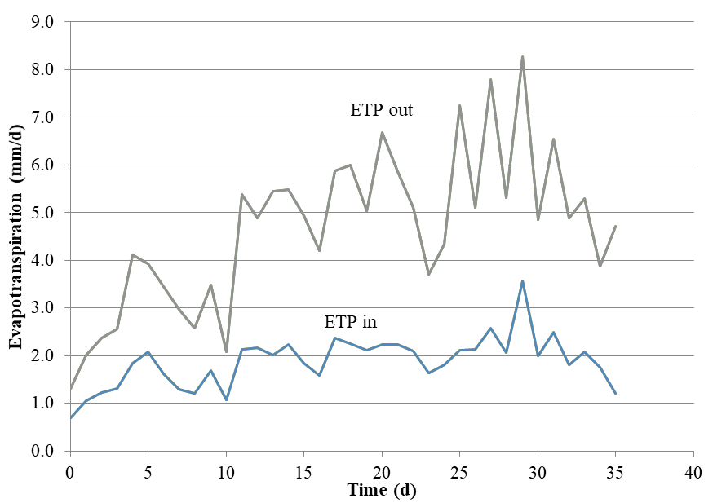
Figure 1. Potential evapotranspiration in the outside (ETP_{out}) and the inside (ETP_{in}) of the planthouse.

3.3. Actual Evapotranspiration
Figure 2 shows the daily water level that may represent water consumed by the plants or the actual evapotranspiration. The daily water level can be estimated with the 3rd order polynomial equation (Eq. 5) resulted in R² 0.998.
h = - 0.00027 t³ + 0.00198 t² – 0.73380 t + 1.5832 (5)
Where h is the water level (mm) and t is time (day).
The total amount of the actual evapotranspiration was about 44 mm. The first derivative of Eq. 5 refers to the daily rate of the actual evapotranspiration, or written as the following equation:
-dh/dt = - 0.00081 t² + 0.00396 t – 0.73380 (6)
As shown in Figure 2, the rate increased as the plant grew initially from 0.73 mm d⁻¹ to 1.86 mm d⁻¹ before the harvest time with the average 1.1 mm d⁻¹. The increase of the actual evapotranspiration with time where the value reaches the peaks at flowering and fruiting was reported earlier by Grewal et al. (2011).
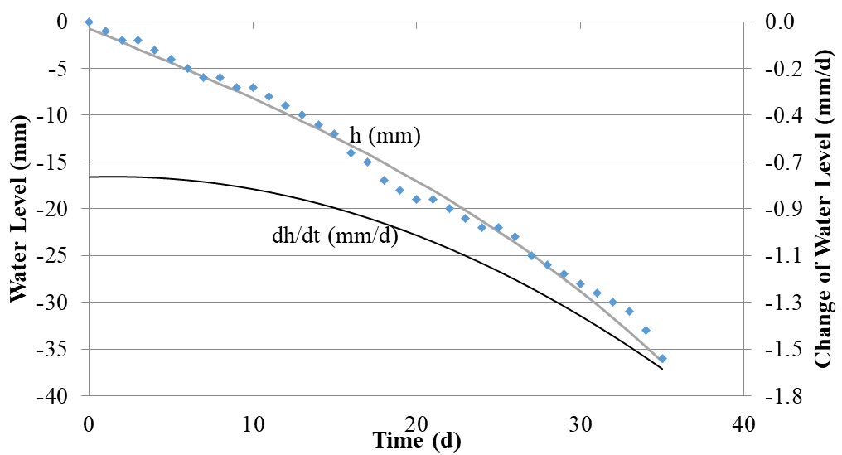
Figure 2. The daily water level during lettuce cultivation
The result suggests that the age of the lettuce influenced much on the actual evapotranspiration (ETc). During the early stage of growth when the lettuces are still small, the water consumption rate is minimal and as the lettuce increased their size, the water consumption rate also increased. Fully developed and mature lettuce plants in hydroponics consumed much water, and the changes in climatic conditions also caused a significant shift in water consumption during the stage of growth (Pelesco and Alagao 2014).

3.4. Crop Coefficients
Figure 3 shows variations of lettuce crop coefficient during plant growth. Kc value of lettuce at the initial stage (on 0th – 6th day after planting) was 0.7 to 0.5, at the middle session stage (on 17th – 23th day after planting) was 0.4 to 0.7, and at the end of the late season stage (on 30th – 36th day after planting) was 0.6 to 1.4. Allen et al. (2006) stated that the general value for lettuce Kc on the field under typical irrigation management and soil wetting at the initial stage is 0.7, at the middle session stage is 1.00, and at the end of the late season, the stage is 0.95.
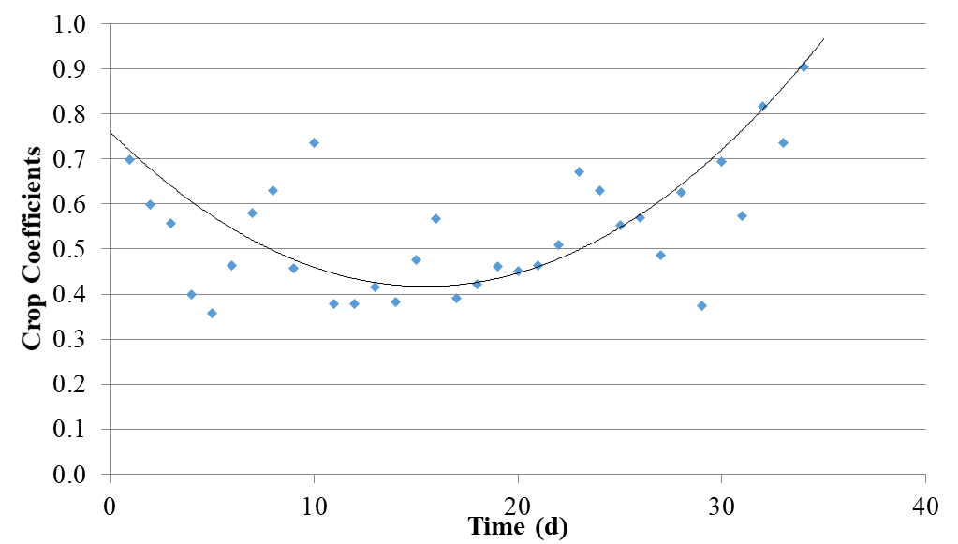
Figure 3. Lettuce Kc values during the planting period
Lettuce Kc during planting period forms a parabolic line with the 2nd order polynomial equation Kc = 0.0014 t² + 0.761, where Kc is lettuce crop coefficient, and t is time (day), with R² = 0.5464.

3.5. Water Productivity
The yield of lettuce in this study was 1114.6 g/m², and water productivity was 29.58 g/l. Figure 4 (a) shows the consumptive water use by the plant to be the dry weight toward the day after planting. Increasing water consumption also increased the dry weight. Consumptive use (CU) can be estimated with the 3rd order polynomial equation resulted in R² 0.9996, with the equation is CU = 0.0001 t² + 0.0031 t + 0.0146, where CU is the water consumption of lettuce (l) and t is time (day). While the dry weight (DW) can be estimated with power equation resulted in R² 0.9803, with the equation is DW = 0.000062 t^{3.2277} where DW is the dry weight of lettuce (g), and t is time (day).
Water productivity rate was from DW equation divided by CU equation. It means every water (l) was consumed will producing the biomass (g/l). In the first 6th day planting period, 0.04 l of consumptive water use was the 0.55 g/l of the dry weight of lettuce. In the middle planting period in the 23rd day, 0.16 l of consumptive water use was the 11.15 g/l of dry weight. And in the harvesting day, 0.35 l of consumptive water use was the 29.58 g/l of dry weight. Water productivity of lettuce in this study was smaller than the productivity of wet lettuce with drip irrigation with limited water supply (Contreras et al. 2008) with a value of 0.61 kg/m³. Based on Figure 4 (b), the water productivity function can be estimated with a linear equation (Eq. 7) resulted in R² 0.9979.
WP = 95.552 CU - 3.792 (7)
Where, WP is the water productivity (g/l) and CU is consumptive use (l).
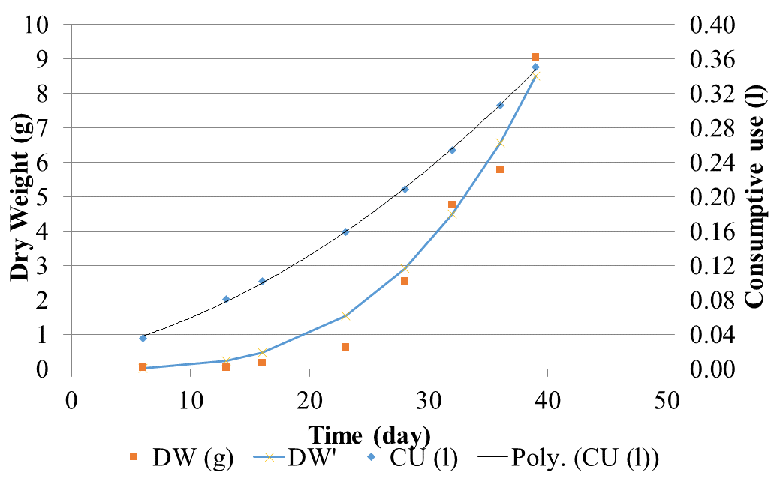 | 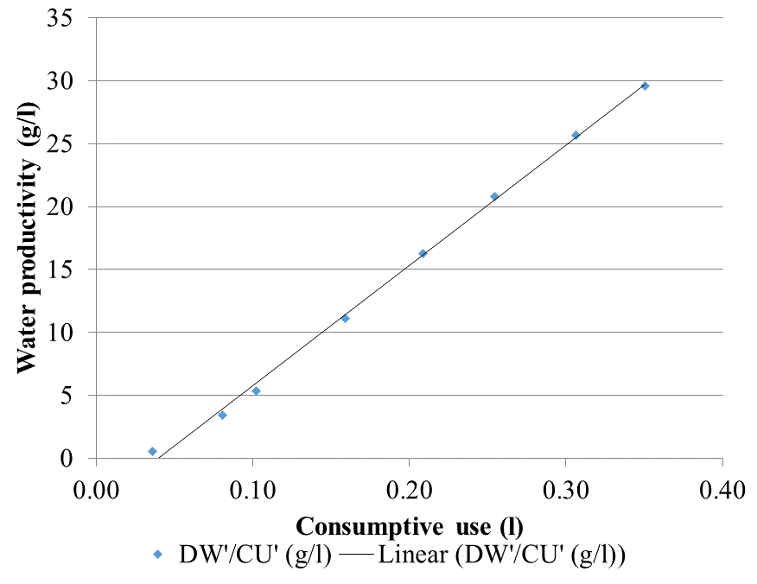
(a) | (b)
Figure 4. (a) Dry weight and water consumption use by lettuce during the planting period (b) Water productivity of lettuce cultivation using a floating hydroponic technique

4. CONCLUSIONS
It is concluded that:
- The climate inside the planthouse was significantly different than that in the outside. In which during 40 days of lettuce cultivation, solar radiation in the inside ranged 3.484–16.303 MJ m⁻² d⁻¹ while in the outside 5.702–33.086 MJ m⁻² d⁻¹, temperatures in the inside the planthouse ranged 21.2º–35.4º C while in the outside 21.0º–34.4º C, and relative humidity in the inside ranged 79.0%–96.7% while in the outside 80.6%–99.6%.
- Potential evapotranspiration inside the planthouse ranged 0.8–4.2 mm d⁻¹ that can be estimated precisely by Hargreaves model with the adjustment coefficient (C_{o}/K_{r}) was 0.0116 instead of 0.0135.
- Crop coefficient (Kc) changed with time forming a parabolic equation started at 0.7 then decreased to reach 0.4 then increase to 1.4 at days of 36.
- Lettuce productivity was 1114.6 g/m² having water productivity 29.58 g/l which was linearly related to the consumptive use of water by the plant.

5. Acknowledgement
The author expresses gratefulness to the Ministry of Research, Technology and Higher Education, Indonesia for providing financial support through PMDSU scholarship.

6. REFERENCES
Allen RG, Pereira LS, Raes D, Smith M. 2006. FAO irrigation and drainage paper no. 56: crop evapotranspiration (guidelines for computing crop water requirements). ROME (IT): FAO of UN.64.
Amiri MJ, Koupai JA, Eslamian S. 2018. Comparison of reference evapotranspiration inside and outside the glasshouse. Int. J. Global Environmental Issues. 7(4): 297-306.
Arif C, Setiawan BI, Sofiyuddin HA, Martief LM, Mizoguchi M, Doi R. 2012. Estimating crop coefficient in intermittent irrigation paddy fields using excel solver. Rice Science. 19(2): 143-154.
Boulard T, Roy JC, Pouillard JB, Fatnassi H, Grisey A. 2017. Modelling of micrometeorology, canopy transpiration and photosynthesis in a closed greenhouse using computational fluid dynamics. Biosystem Engineering. 158: 110-133.
Castillo FG, Sarrıa FA, Rubio FCC. 2018. Calibration and spatial modelling of daily ET0 in semiarid areas using Hargreaves equation. Earth Sci Inform. 11(3): 325–340.
Contreras S, Mark AB, David T. 2008. Restricted Water Availability During Lettuce Seed Production Decreases Seed Yield per Plant but Increases Seed Size and Water Productivity. Hort Science. 43(3): 837-844.
Cossu M, Murgia L, Ledda L, Deligios PA, Sirigu A, Chessa F, Pazzona A. 2014. Solar radiation distribution inside a greenhouse with south-oriented photovoltaic roofs and effects on crop productivity. Applied Energy. 133: 89–100.
Grewal HS, Maheshwari B, Parks SE. 2011. Water and nutrient use efficiency of a low-cost hydroponic greenhouse for a cucumber crop: An Australian case study. Agricultural Water Management. 98(5): 841-846.
Haraguchi T, Saptomo SK, Inosako K, Yuge K, Mori K, Nakano Y. 2005. Numerical estimation of evapotranspiraton rate in a greenhouse. J. Agric. Meteorology. 60(5): 669-672.
Hargreaves GH, ASCE F, Allen RG. 2003. History and evaluation of Hargreaves evapotranspiration equation. J. Irrig. Drain Eng. 129(1): 53-63.
Hassanien RHE, Li M, Lin WD. 2016. Advanced applications of solar energy in agricultural greenhouses. Renewable and Sustainable Energy Reviews. 54: 989–1001.
Koesmaryono Y, Sugimoto H, Ito D, Sato T, Haseba T. 1997. The influence of different climatic conditions on the yield of soybeans cultivated under different population densities. J Agric. Meteorology. 52(5): 717-720.
Lamnatou C, Chemisana D. 2013. Solar radiation manipulations and their role in greenhouse claddings: Fresnel lenses, NIR- and UV-blocking materials. Renewable and Sustainable Energy Reviews. 18: 271–287.
Maclean H, Dochain D, Waters G, Stasiak M, Dixon M, Straeten DVD. 2012. A Simple Mass Balance Model for Lettuce-the Water Balance. IFAC Proceedings Volumes. 45(16): 1442-1447.
Mao X, Liu M, Wang X, Liu C, Hou Z, Shi J. 2003. Effects of deficit irrigation on yield and water use of greenhouse grown cucumber in the North China Plain. Agricultural Water Management. 61: 219-228.
Mobtaker HG, Ajabshirchi Y, Ranjbar SF, Matloobi M. 2016. Solar energy conservation in a greenhouse: Thermal analysis and experimental validation. Renewable Energy. 96: 509-519.
Patel J, Patel H, Bhatt C. 2014. ECALTOOL: fuzzy logic based computer program to calibrate the Hargreaves equation for accurate estimation of evapotranspiration. Agric Eng Int: CIGR Journal. 16(3): 245-250.
Pelesco VA, Alagao FB. 2014. Evapotranspiration Rate of Lettuce (Lactuca sativa L., Asteraceae) in a Non-Circulating Hydroponics System. Journal of Society & Technology. 4: 1-6.
Suhardiyanto H, Arif C, Setiawan BI. 2009. Optimization of EC Values of Nutrient Solution for Tomato Fruits Quality in Hydroponics System Using Artificial Neural Network and Genetic Algorithms. ITB Journal of Science. 4(1): 38-49.
Takakura T, Kubota C, Sase S, Hayashi M, Ishii M, Takayama K, Nishina H, Kurata K, Giacomelli GA. 2009. Measurement of evapotranspiration rate in a single-span greenhouse using the energy-balance equation. Biosystem Engineering. 1(2): 298–304.
Tyagi NK, Sharma DK, Luthra SK. 2000. Determination of evapotranspiration and crop coefficients of rice and sunflower with lysimeter. Agricultural Water Management. 45: 41-45.
Zhang Y, Kendy E, Qiang Y, Changming L, Yanjun S, Hongyong S. 2004. Effect of soil water deficit on evapotranspiration, crop yield, and water use efficiency in the North China Plain. Agricultural Water Management. 64: 107-122.
Zhang ZK, Liu SQ, Liu SH, Huang ZJ. 2010. Estimation of cucumber evapotranspiration in a solar greenhouse in Northeast China. Agricultural Sciences in China. 9(4): 512-518.

