Development of a manually operated Palm oil extraction machine

Murshed Alam, Rajesh Nandi*, Ehsanul Kabir

)Department of Farm Power and Machinery, Bangladesh Agricultural University, Mymensingh-2002, * Corresponding author: rajesh@bau.edu.bd)

Abstract
The palm farmers of Bangladesh are suffering for want of an extraction machine. Therefore, a research was undertaken to develop a manually operated palm oil extraction machine at the Department of Farm Power and Machinery, Bangladesh Agricultural University. It is a press type machine. A screw leads a piston manually in a perforated cylinder to press the mesocarp (pulp of palm fruit) to extract oil. The volume of the cylinder of the machine was found 0.033 m3 and maximum 20 kg fruits can be accommodated at a time. The amount of crude palm oil extraction at full capacity of the machine was found 8 kg/hr., which is higher than any manually operated extracting machine available in the market. The crude oil extraction efficiency of the machine without palm kernel was also found satisfactory. Application force on screw can be increased by increasing the length of the handle and number of persons according to filling condition of the cylinder. The machine was developed with locally available materials for having low purchase price and smooth repair and maintenance. So that, it will be easily affordable to the palm farmers of Bangladesh. The developed machine will solve the burning need of palm farmers in Bangladesh.

Keywords: Palm oil, extraction machine, extraction efficiency, application force, purchase price

1. INTRODUCTION
Bangladesh is deficit in oils and fats since long. She produces only 10 percent of its requirement of oils and fats and hence has to import the rest 90 percent. Palm, soyabean and canola/mustard oils are the major three edible oils consumed in the country. Oil palm (Elaeis guineensis) is a perennial crop and the principal source of palm oil. Palm oil is the dominating edible oil since 2003. In 2012, palm oil occupied about 64 percent market share among the three major edible oils followed by soyabean oil with 28 per cent market share and canola/mustard oil with 8.0 percent share. During the period from 2009 to 2012, import of palm oil in Bangladesh was in and around one million tons occupying about 64-68 per cent of total import of oils and fats. It is to be mentioned that in 2009, import of palm oil in the country exceeded one million tons for the first time (Alam, 2013).
Palm trees are available in many areas in our country, such as Chittagong, Barisal, Tangail, Jamalpur, Madhupur, Meherpur, Mymensingh, Rangpur, Comilla, Khagrachhari, Faridpur, Jessore, Khulna, Dinajpur & Sylhet. But, due to lack of palm oil processing technology, every year lots of palm fruits are wasted. At present palm oil is extracted in our country by traditional method. This method is laborious and time consuming; on the other hand, the oil extraction efficiency is very low. This method is not profitable so farmers are losing interest from palm cultivation. Yesmin and Rahman (2013) found from a survey, that 70% of respondent, they had asked at Phulpur upazilla from Mymensingh and Meherpur sadar upazilla from Meherpur do not have machines that are used in palm oil extraction. They also founded that, some of the people are using traditional method and boiling method to extract palm oil. Both the methods are not suitable for extraction of high quality palm oil. It is done for small-scale purpose. Ikechukwu et al. (2012) stated that the mechanical extraction method uses screw press as the principal means of extracting vegetable oil. However, use of the screw press for full extraction has been increased over the years in the less developed countries. But, existing imported screw press machines for oil palm are very expensive and not readily affordable by small and medium scale processors who form the majority of the processors. Industries established with imported technology do not function for a long period of time because of lack of spare parts and inadequate maintenance. It is essential to evolve indigenous technology to address the issue of palm oil processing in Bangladesh.

Considering all the prospects and problem regarding palm oil processing, it is necessary to design and develop a palm oil extraction machine. This work was to design and develop a user friendly manually operated palm oil extraction machine.

2. MATERIALS AND METHODS
2.1 Determination of physical properties of palm fruit
Randonly selected palm fruits (Elaeis guineensis) were measured by slide calipers to determine the size. The average length and breadth of palm fruits were found 3.37 cm and 2.02 cm respectively. The average mass of palm fruit was found 10.8g, which was measured by an electrical balance (ENTRIS822-1S,0.01g, Sartorius Lab Instruments GmbH & Co. KG, Germany). Mass of palm kernel varied from 2 to 4 gm. The volume of palm fruit varied from 10 to 12 cm³ was determined by a volume-measuring cylinder. To determine the density of mesocarp, the volume of a definte amount of mesocarp was also determined by the volume measuring cylinder. With the help of weight and volume of mesocarp, density was calculated using the following formula:
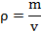
Where, = density of mesocarp, kg/ m³
m = mass of the mesocarp, kg
v = volume of the mesocarp, m³
The density of mesocarp was found 659.40 kg/m³. The pressure required to express oil from mesocarp was determined by keeping the fruit under a crushing machine until oil come out from the fruit. The average pressure required to express oil from mesocarp was found 1.04 N/mm². Physical properties of palm fruits will help to understand the crude oil extraction process. Data were recorded and descriptive statistics of different physical properties of palm fruits were calculated using MS Excel software.

2.2. Design consideration
The machine was designed and developed based on the following considerations: The machine should be simple in construction, it should have simple adjustment and easy to operate, it should be made with locally available materials with simple technology, it should be easy to repair and maintain, the cost of machine must be within the capacity of small and medium farmer. The machine consists of main-frame, piston with threaded rod, perforated cylinder and these were designed by AutoCAD and developed for the proposed study.
2.3 Design and development of different parts of palm oil extraction machine

2.3.1 Design and development of perforated cylinder of the machine
Mass of required material, m = 20 kg
Density of mesocarp, d = 659.40 kg/m³
Therefore volume, v = m/d = 0.030 m³
Considering 10 % allowance
Total volume of the cylinder = (0.030 + 0.003) m³ = 0.033 m³
Now, v = πr²h
Where, volume of the cylinder, m³
r = radius of the cylinder, m
= constant (22/7)
h = height of the cylinder, m

Now considering for convenience using of the machine let, the diameter of the cylinder is 304 mm. Height of the cylinder is 457 mm. It is perforated 228 mm from bottom to top. A round perforated sheet of 304 mm diameter attached to the bottom of the cylinder. Photographic view of perforated cylinder are given in Fig.2.1.

According to Levinson (1970) the hoop stress in a thin walled cylinder is given as:
σ_{h} = Prn/t
t = Prn/σ_{h}
Where,
σ_{h} = hoop stress, N/mm²
P = Pressure required to express oil from mesocarp
t = thickness of the perforated cylindrical cage, mm
n = factor of safety
R = radius of the perforated cylindrical cage, mm
For yield strength of mild steel = 250 N/mm² and considering a factor of safety, N = 3
The thickness of the perforated cylinder is 2 mm.

(a) | (b)
Figure 2.1 Perforated cylinder; a) complete cylinder, b) close view of the perforated part of the cylinder

2.3.2 Design and development of frame of the machine
The frame of the machine was constructed with mild steel angle bars (Fig. 2.2). It holds the piston. A nut was fitted in to the center of the frame that holds the collar through which the screw is driven. The frame is attached with perforated cylinder.

2.3.3 Design and development of container of the machine
The container was constructed with mild steel sheet (Fig. 2.3). It helps to collect the oil by preventing the splashing out of oil from the perforated cylinder.

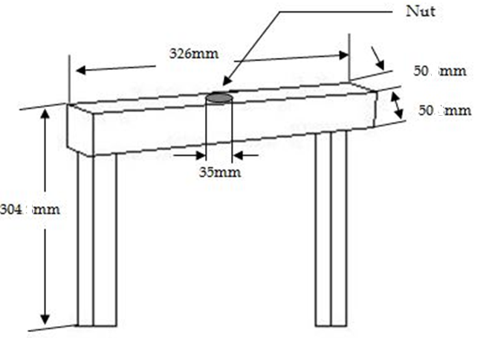 | 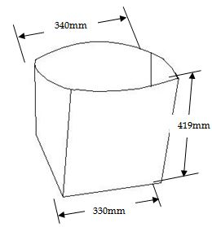
Figure 2.2 Frame to hold the piston | Figure 2.3 Container to collect oil

2.3.4 Design and development of supporting frame of the machine
The supporting frame was constructed with mild steel sheet and flat bar (Fig.2.4). The height of the supporting frame is 127 mm and width is 344 mm. Each stands of the supporting frame has a hole of 6 mm diameter so that, the machine can be fixed at any place by locking the stands with bolt.

Load on the supporting frame = Weight of the machine + Load required to express oil from mesocarp
Weight of the machine = (18.5 x 9.81) N = 181.485 N
Load required to express oil from mesocarp = Pressure required to express oil x Area of the cylinder
= 1.04 N/mm² x πr²
= 1.04 x 3.1416 x 152² N
= 75486.86 N
Therefore, load on the supporting frame, W = (181.485 + 75486.86) N
= 75668.35 N
Now load on each stand, L = (75668.35/ 4) N = 18917.08 N
Yield strength of mild steel, s = 250 MPa = 250 N/mm²
Now for the design, L/A = s/N
Where,
N = Factor of safety
A = Cross sectional area of square stand = b²
b = breadth of the square bar
Cosidering a factor of safety, N = 3
The breadth of each square stand, b = 15 mm
2.3.5 Design and development of threaded rod of the machine
A Belgium rod of 35 mm diameter is used as threaded rod. Then threads were cut. The threads of the rod were v-shaped. A GI pipe was attached at the top of the rod. This GI pipe is used as a handle for rotating the threaded rod. Front view of threaded rod is given in Fig.2.4.

2.3.6 Design and development of piston plate of the machine
The piston plate of the machine is a mild steel plate. The piston plate was attached at the bottom of the threaded rod. Fig. 2.6 shows front view of the piston

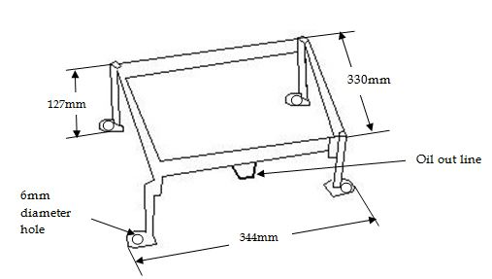  Figure 2.4 Supporting frame | 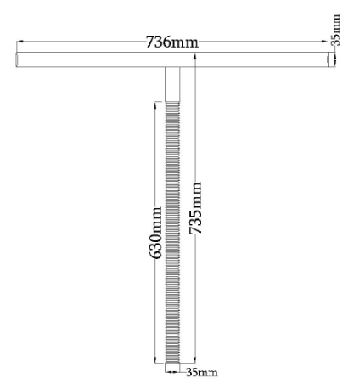  Figure 2.5 Front view of the threaded rod
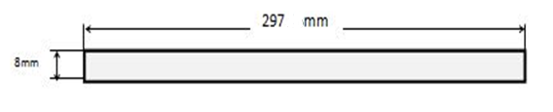
Figure 2.6 Front view of piston plate

2.4 Performance test of the machine
2.4.1 Collection and processing of palm fruit
Palm fruits were collected from Dhampti village of Debidwar upazilla. After collecting the fruits, it was cleaned in order to remove the foreign materials. Two kilogram of palm fruit was taken into a pan. Then the fruits were boiled with water for an hour. After boiling the palm fruits, it was kept in open air for few minutes. So that, the extra water from the palm fruits can be removed. After separating mesocarp from the kernel, the weight of the mesocarp was recorded. Then Palm fruit pulps were poured into the machine and it was pressed to extract crude palm oil. After getting the crude oil, it was boiled to remove the moisture and kept for few minutes so that the sludge settles down to the bottom. Then oil of the upper portion is collected as edible oil.

2.4.2 Calculation of the performance parameters of the machine

Capacity of the machine: Capacity of the machine was determined by following equation,
C = W_{p}/t
Where, C = capacity of the machine, kg/hr.
W_{p} = weight of mesocarp (palm fruit pulp), kg
t = time required to extract the crude oil, hr.

Crude oil extraction efficiency of the machine (without palm kernel)
Crude oil extraction efficiency of the machine was determined by following equation,
e = (W_{o}/W_{p}) x 100
Where, e = crude oil extraction efficiency of the machine
W_{o} = weight of crude oil, kg
W_{p} = weight of mesocarp (palm fruit pulp), kg

2.4.3 Cost calculation
Production cost of 1kg crude palm oil was determined by following equations,
P = AC/A_{f}
Where, P = production cost, tk/kg
AC = operating cost of the machine, tk/hr.
A_{f} = amount of crude palm oil extraction at full capacity of the machine, kg/hr.

Operating cost of the machine can be determined by following equations,
Operating cost, AC = Fixed cost + Variable cost
Fixed costs are the costs of that are independent from the size of production. It can be determined by following equations,
Fixed cost = D + T + I_{i} + I_{n} + S

Where, D = depreciation = (P-S)/l
Here, P = purchase price of machine
S = salvage value (10% of Purchase price of the machine)
l = expected life time of machine (10 years)
T = tax (1.5% of Purchase price of the machine)
I_{i} = interest on investment, = {(P+S)/2} x i
i = interest rate (9%)
I_{n} = insurance ( 0.25% of Purchase price of the machine )
S= shelter

Variable costs of the machine were reflected by the cost of labour, oil, fuel, repair and maintenance and timeliness cost of the machine. It can be determined by following equations,
Variable cost= L+O+F+T+R&M
Where, L= labor cost
O= oil cost
F= fuel cost
T= timeliness cost
R&M= repair & maintenance cost

3. RESULTS AND DISCUSSION
3.1 Working principle of the designed machine
The manually operated palm oil extraction machine was constructed after assembling all the required parts. It was very simple in design and easy to handle . The design of the machine is shown in Fig. 3.1. The manually operated palm oil extraction machine was developed in the workshop of Farm Power and Machinery department, Bangladesh Agricultural University The developed palm oil extraction machine was shown in Fig. 3.2.

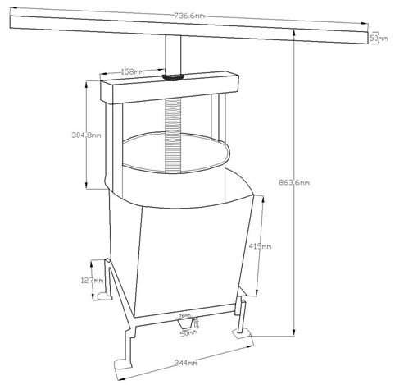 | 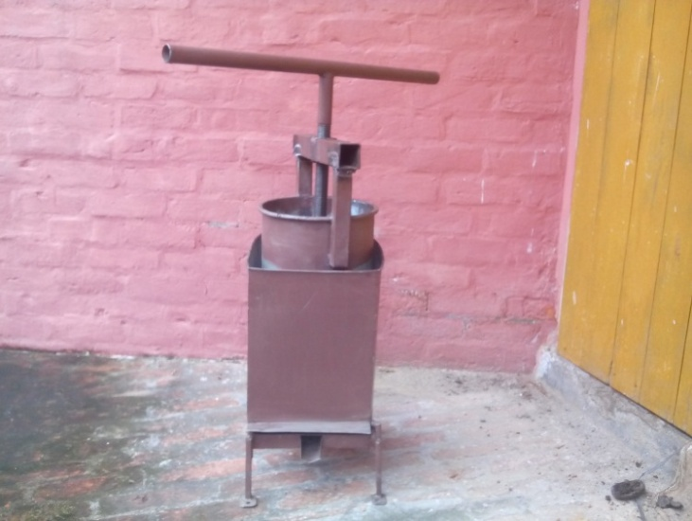
Figure 3.1 Design of manually operated oil extraction machine | Figure 3.2 Photographic view of developed machine

By rotating the threaded rod, the piston plate attached with it goes up and down. When it rotates clockwise, the piston goes down and it pushes the palm fruit towards bottom of the cylinder. Then it compresses the palm fruit and oil comes out from it. Oil comes out through the perforated cylinder to the oil out line. When compressing is done then the threaded rod is rotated counter clockwise and the piston goes up. By taking the piston to the top of the cylinder, it is cleaned by removing the debris from the cylinder. Then it is ready for another compression. Working principle of the designed machine is given in Fig.3.3.
\

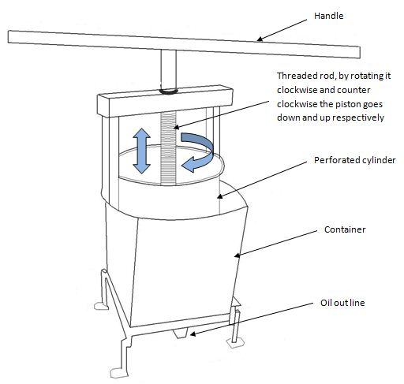
Figure 3.3 Working principle of the designed machine

3.2 Performance parameters of the machine
The volume of the cylinder of the machine was found 0.033m³ and maximum 20 kg mesocarp can be accommodated at a time. On the other hand, the compression force can be increased by increasing the applied force in the handle. Therefore, it has an advantage to use any amount of fruits (maximum 20 kg) at a time to extract crude.. The crude oil extraction efficiency without palm kernel was found 19%. FAO (2002) reported that fresh fruit without the kernel contains about 20% to 24% oil and the first-pressing oil extraction efficiency range from 12 to 15 percent for the spindle-presses and repeated pressing oil extraction efficiency ranges from 20 to 24 percent. Therefore, the result from this experiment is very close to the standard value. The amount of crude palm oil extraction at full capacity of the machine was found 8 kg/hr., which is higher than any manually operated extracting machine available in the market.

3.3 Cost analysis
Designed machine was constructed with the locally available materials like mild steel. The cost of the machine is only BDT 10,000 that is affordable by the palm farmers of Bangladesh. Table 1 shows the detail of the costing required to develop the machine. Assuming, labor cost is 37.5 BDT/hr., repair and maintenance cost is 0.5% of purchase price of the machine, expected life is 10 year. It is also assumed that the machine is used minimum 2500 hr. This machine does not need fuel, shelter and timeliness cost. Therefore, the operating cost of the machine was found 75.63 BDT/hr. and production cost of crude palm oil was 9.5 BDT/kg.

Table 1. Cost of the machine
Item | Amount (BDT)
M.S. Sheet (.7mm) | 600
M.S. Sheet (1.5mm) | 1500
M.S. Angle Bars, square bars & nut | 700
M.S. Plate (8mm) | 500
Threaded Belgium rod | 3000
G.I. Pipe | 100
M.S. Sheet (2mm) boring & round shape | 1500
Finishing & coloring | 300
Labour wage | 1800
Total | 10000

4. CONCLUSIONS
A manually operated palm oil extraction machine was developed to overcome the problem regarding palm oil extraction. The machine is made of mild steel and cost is only BDT 10,000 which is affordable by the palm farmers of Bangladesh. In addition, if the machine is manufactured commercially then the price will be reduced to BDT 8,000. The working principle of the machine is very simple and easy to handle. Most of the palm farmers don’t have access to electricity in their locality so this machine is suitable for them. On the other hand, the weight of the machine is only 18.5 kg so a farmer can easily carry the machine and fix anywhere near the garden. The extraction efficiency (without palm kernel) of the machine is 19% which is very close to the reported average value and very higher than traditional method (just by boiling). Further study is required to test the performance of the machine in farmers’ field. Then this machine might be introduced in Bangladesh and it will solve the burning need of palm farmers in Bangladesh.

References
Alam A., Fakhru M. (2013): Report on Palm oil dominates in Bangladesh market. The Financial Express, Regional Manager, Malaysian Palm Oil Council.
FAO 2002: Small scale palm oil processing in Africa. FAO Agricultural Services Bulletin, 148: 1-56.
Yesmin F, Rahman F 2013: Study on Palm Oil Extraction. Project Report. Department of Farm Power and Machinery, Bangladesh Agricultural University.
Ikechukwu AG, Okeke AC, Chima LO 2012: A Plant Design for Mechanical Extraction of Nmanu Aki (Palm Kernel Oil) Using Complete Pretreatment Process. Proceedings of the World Congress on Engineering and Computer Science, 2: 123-130.

