**DEVELOPMENT OF A MODIFIED PALM-NUT CRACKER**

E.I. Alade*; O.A. Koya; B.V. Omidiji

Department of Mechanical Engineering, Obafemi Awolowo University, Ile-Ife, Nigeria

**Abstract**

This study examined the major shortcomings of conventional crackers, and developed a modified palm-nut cracker with the view of reducing the level of mechanical kernel damage. Equation relating the required speed for cracking operation and force requirement in fracturing the nut was expressed, and the force was experimentally determined before machine development. The machine was designed and fabricated based on standard engineering principles for part-sizing and selection of materials. The machine was tested with *dura* nuts classified into four groups of sizes and varied during experimentation. The performance evaluation of the machine showed that cracking efficiency ranged between 86.10-97.27% at an average value of 4.49% kernel breakage and whole kernels ranging between 94.85-95.97%. Results were analysed using one way Analysis of Variance (ANOVA) at 0.05 level for influence of different nut sizes and feed rates on machine performance indices. The results indicated that the modified machine is suitable for processing palm nuts of all sizes when operated at moderate feed rates.

Keywords: Palm-nut cracker, nut cracking, feed rate, cracking efficiency, performance evaluation

1. **Introduction**

The cracking of palm nut, a composite biomaterial consisting of an outer hard shell and embedded softer kernel, which is extracted for the production of Palm Kernel Oil (PKO) leaving the palm kernel meal as residue, is a significant step that usually affects the quality of kernel. Hence, preservation of this fragile kernel embedded in the palm nut is very important and depends, among other things on efficient nut-cracking which enhances effective kernel-shell separation as well as the subsequent quality of the palm kernel oil (Koya and Faborode, 2005; Gbadam *et al*., 2009). Cracking occurs when a material breaks without entire separation and nut cracking, therefore, occurs when palm-nuts are loaded to rupture without crushing the embedded kernel. Prior to cracking, the nuts are dried sufficiently to enable the kernel shrink away from the shell, in order to reduce kernel breakage. The nuts are then cracked in a machine or manually (Manuwa, 1997; Koya and Faborode, 2005).

Palm nut cracking machines are developed on the principle of hurling of the palm nuts at a fairly high speed against stationary hard surface (Okoli, 1997). Generally, there are two types of modern crackers, the hammer-impact and the centrifugal-impact types. The hammer-impact type breaks or cracks the nut by impact when the hammer falls on the nut, while the centrifugal-impact nut cracker uses centrifugal action to crack the nut.

The economic importance of palm kernel is indicated by its extensive use as food, traditional medicine, and in the cosmetic and confectionary industries (Akinoso *et al*., 2009; Koya *et al*., 2004). In view of these, its demand in global markets has ever been increasing and interest in effective palm kernel extraction is growing.

In the recent years, various researchers and engineers (Ilechie, 1985; Babatunde and Okoli, 1988; Manuwa, 1997; Obiakor and Babatunde, 1999; Olakanmi, 2004; Koya and Faborode, 2005; Koya, 2006; Olukunle *et al*., 2008; Jimoh and Olukunle, 2012) had developed different types of prototypes and concepts for mechanized palm nut cracking devices. So far, palm nut cracking operation had recorded certain level of feat, the process however has quite a number of deficiencies, notably, high operational speed of the existing cracking devices makes design modification a necessity in order to minimize mechanical damage and improve the recovery of the products. Other defects of the existing crackers include: kernels breakages, which may be due to insufficient nut dryness, uncracked nuts in the finished product, which may be caused by inappropriate spacing of blow bars as well as the high nut feeding rate into the cracking chamber. Fortunately, the knowledge of minimum impact force required for nut cracking relevant to the design improvement of the existing mechanical nutcrackers has been investigated (Ofei, 2007; Koya and Faborode, 2005). The focus of this study was therefore aimed at developing a modified palm-nut cracker that minimizes kernel breakage for enhanced subsequent product separation.

**2. Materials and Methods**

**2.1 Analysis of Nut Cracking Process**

In order to estimate the impact force on the nut impinging on the cracking ring, the kinetic energy of the moving nut is equivalent to the energy absorbed upon impact (Koya, 2006). Thus; for a centrifugal impact cracker to impinge the palm nuts repeatedly against the stationary wall of the cracking chamber:

Kinetic energy = Energy absorbed upon impact

That is;

Energy absorbed upon impact = mv2 (1)

But energy absorbed upon impact is the average work required to deform the nut (Khurmi and Gupta, 2005).

Therefore;

W =  (2)

Where F is the applied force (otherwise referred to as cracking force, N) to the nuts andis the deformation of the nut, m. Equation 2 expresses the energy of nut deformation, Nm.

Consequently,



Therefore,

 (3)

From Equation 3, the following relationship for the determination of operational speeds required for palm nut cracking applies:

 (4)

Where  is speed of impacted particles, m/s and is mass of the nut, kg.

**2.2 Experimental Determination of Nut Cracking Force**

The cracking force (*F*) required to crack different nut sizes were experimentally determined using the Instron Universal Testing Machine (INSTRON 3369, USA) as shown in Figure 1.This was achieved by determining the compressive loads to induce nut breakage, as well as their corresponding energy of nut deformation. The testing machine was connected to a computer equipped with the appropriate software, which monitored and plotted the load-deformation curves for the specimen of palm nut being tested.

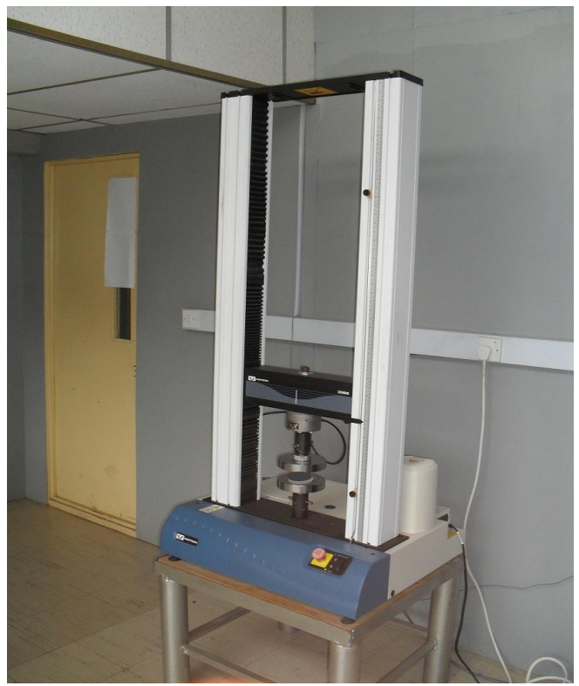

**Figure 1: Loading of palm nut sample for compression load test between two parallel**

**plates**

The required speeds for palm nut cracking shown in Table 1, were then determined using Equation 4. *Dura* variety of palm nut sample which is classified as thick-shelled with large kernel, resistant to cracking and prone to kernel breakage (Hartley, 1977), was selected for this study. Badmus (1990) reported that typical African *dura* nut is about 8‒20mm in diameter and has a fairly uniform shell thickness of about 2mm. The values of the nut properties required for this study were taken from Koya *et al*., (2004) and Alade, (2017) as determined in recent study.

**Table 1: Operational Speeds Determined for Palm Nut Cracking**

|  |
| --- |
| Nut Dura (MC, 13.4%)  Properties/sieve size (mm) 10 14 20 25 Remarks |
| Mass (kg) 3.02 5.16 10.41 11.88 Koya *et al*., 2004  Energy of deformation (Nm) 0.3988 0.9496 1.0516 1.1718 Alade, 2017  Required speed (m/s) 16.25 16.72 14.21 14.05 Computed using  Equation 4 |

Hence, for repeated impact on the nut by the modified machine, the speed found suitable to implement palm nut cracking at relatively minimum impact which may minimize mechanical damage, was taken as 10.32 m/s (86 rad/s) when compared with the speed for cracking process when Buckingham’s π theorem was used in a recent study (Alade, 2017).

**2.3 Machine Description and Development**

The modifications made in addressing the identified shortcomings were nuts pre-screening and grading into large, medium and small size categories for cracking; repeated impact cracking of the graded nuts using the determined minimum cracking speed and incorporation of external kernel-shell pre-cleaner cum classifier with the cracker. The modified palm-nut cracker therefore mainly consists of hopper, cracking chamber and pre-cleaner cum classifier. Palm nuts are primarily pre-screened to remove dirt and immature nuts, categorized into four size grades and then loaded into the machine through the hopper, in batches for nut cracking. The cracked mixture is then transported to the external pre-cleaner cum classifier, to further remove dirt, immature kernels and smaller shell particles, before proceeding to classify the mixture of kernel and shell based on their sizes.

**2.3.1 The hopper**

            The hopper (Figure 2) is essentially the inlet for the palm nuts into the machine and regulated through the feed gate. It was made of 2 mm mild steel plate to ensure rigidity, and as a pyramidal frustum (350×100×350mm) with flanks inclined at 700, greater than the dynamic angle of repose of palm nut on mild steel, for free flow of the nuts into the cracking chamber. The volume and holding capacity of the hopper was determined for a batch feeding of 13.5 kg palm nuts into the cracking chamber.

**2.3.2 The cracking chamber**

The cracking chamber (Figure 3), takes the shape of a hollow cylindrical tube with beaters at its core. The cylinder measures 380 × 400mm in its minor and major diameters respectively, and 200mm in its length. The cracking chamber is bored at the circumferential centre through the back surface to enable the passage of the driving shaft, to the core of the chamber through the ball bearing. The cracking chamber is made of mild steel with 10mm thickness to ensure adequate

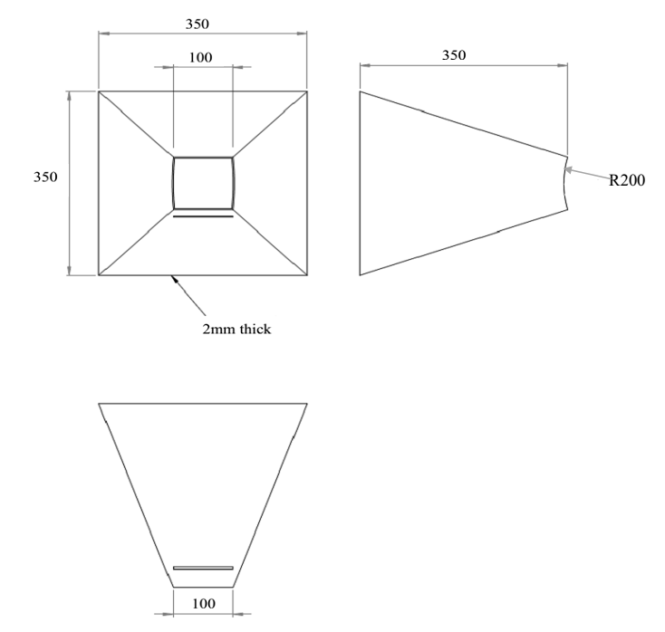

All dimensions in mm

**Figure 2: Orthographic projections of the feed hopper**

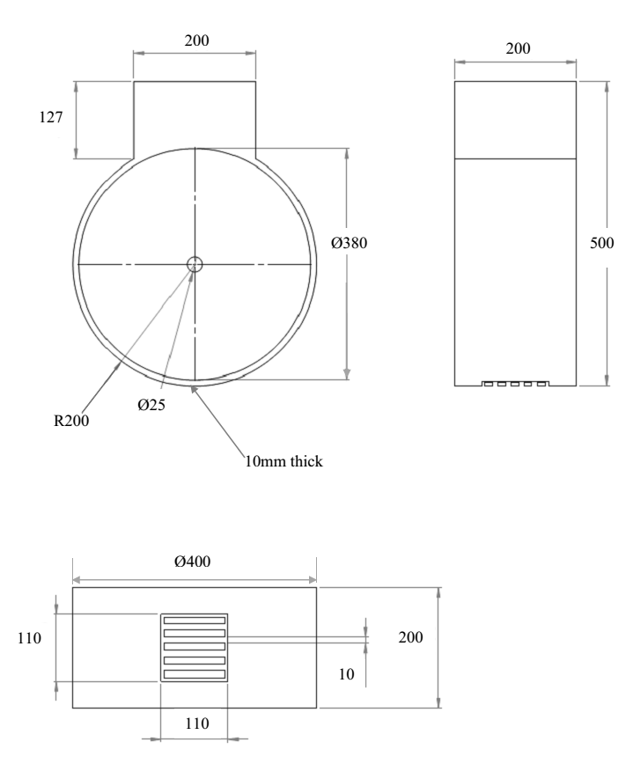

All dimensions in mm

**Figure 3: Orthographic view of the cracking chamber**

strength and rigidity to withstand the repeated impact force during cracking. The cracking process is achieved by the impact force exerted on the nuts against the walls of the cracking chamber. As the nuts are being fed to the cracking chamber are struck against the walls of the chamber by the rotating beaters by centrifugal action, impact force is generated to loosen kernels from the shells. The cracked mixtures are then transported to the precleaner cum classifier chamber via the discharge unit.

**2.3.3 The cracking beater**

The beater is made of mild steel and schematically shown on Figure 4. The shape of the beater was adopted to ensure that each palm nut fed into the cracking chamber is impacted against the wall of the chamber by the beater. Also, a radius of 120 mm was selected for designing the beater as it falls within the range of most of the existing designs of commercialized palm nut crackers.

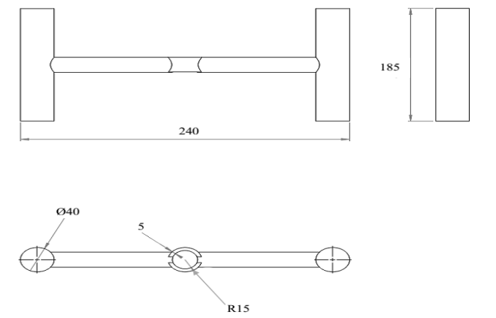

All dimensions in mm

**Figure 4: Orthographic view of cracking beaters**

**2.3.4 The pre-cleaner and classifier**

This section (Figure 5) mainly composes of rotating screen and shaft. A pre-screening section was incorporated to screen out dirt and immature kernels while the other section is designed to classify kernel-shell mixture. This was to enhance better product purity. The physical properties of kernel and shell such as differences in sizes and shapes were considered in the development of this compartment which mainly consists of rotating cylindrical screen and shaft. In most cases, shells are flat or dish shaped, while kernels vary from nearly spherical to ellipsoidal in shape. Also, it has been established that the least mean diameter of palm kernels is greater than 10 mm (Akubuo and Eje, 2002; Koya *et al.,* 2004; Koya and Faborode, 2005). It was expected that mixture of kernel and shell particles smaller than these kernels would be classified after mechanical cracking process. Consequently, sieve cleaner with regular apertures of 10 mm was used as classifier. It was a cylindrical framework 900 mm long with diameter of 350mm (Figure 5). A section of the frame, 300mm long, near the feed-end, overlaid with net of uniform 5mm apertures, was used as pre-cleaner, to sieve out small shell particles and immature kernels, while the remaining length was the classifier. The unit is mounted on the supporting frame through the driving shaft and directly attached to the outlet discharge of the cracking chamber, and it was made up of galvanized steel and expanded metal.

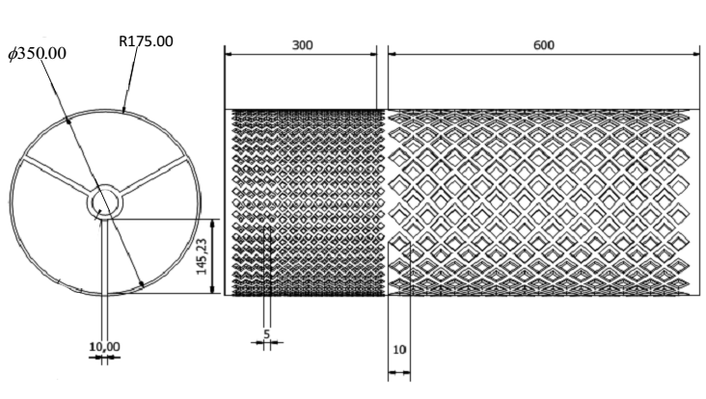

All dimensions in mm

**Figure 5: Orthographic views of pre-cleaner and classifier**

**2.3.5 Final assembly of the cracking unit**

After all the components were developed, all the unit members were finally assembled (Figure 6), having its dimensions as shown. The driveshaft carrying the pulley and two bearings were coupled to the cracking chamber which had been initially attached to the cracking beater. The hopper is vertically linked to the cracking chamber to ensure free fall of the palm nuts by gravity into the chamber. The pre-cleaner cum classifier section is also externally attached to the chamber and supported by another shaft carrying its pulley. The entire framework is firmly coupled to the chassis member through welding and bolt and nuts where necessary.

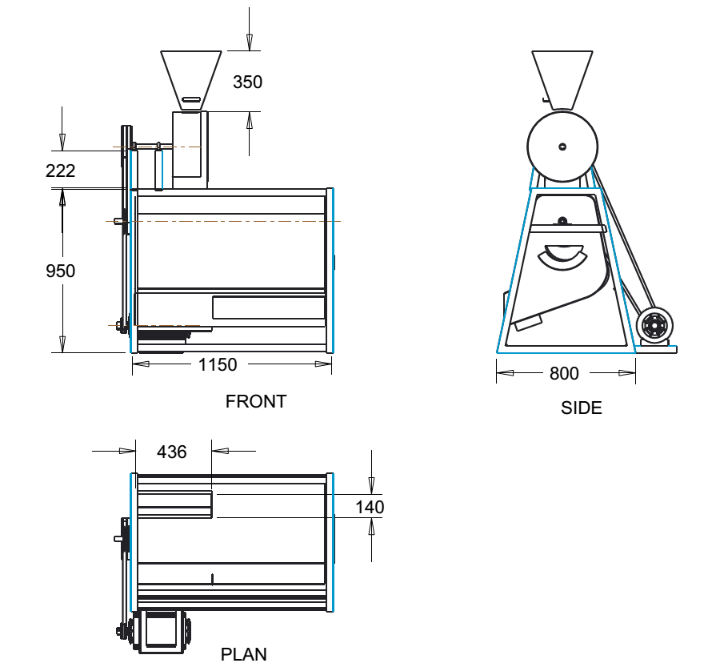

All dimensions in mm

**Figure 6: Orthographic views of the cracking unit and pre-cleaner cum classifier**

**of modified machine**

**2.3.6 Machine drive**

The drive division of the machine consists of the electric motor, the pulleys and the belt drive. The section integrates the basic units of the modified machine and thereby minimizes energy consumption. A single - phase electric motor with initial driving speed of 1410 rpm was firmly mounted on the supporting frame to serve as the power source. Power is transmitted from the motor to the machine through V – belts and pulleys arrangements. The pulleys range in diameter of sizes 110 mm (cracking) to 600 mm (pre-cleaner cum classifier).

**2.4 Design Analysis**

**2.4.1 Hopper:**

The hopper was expected to handle nut capacity of 13.5 kg in a batch feeding. Therefore, the volume (V) of the hopper was determined using the following relationship:

V =  (5)

The density is the nut bulk density which had been experimentally determined and proposed by researchers (Koya *et al*., 2004; Ezeoha *et al*., 2012);

V = 

V=0.019 m3

To achieve the designed volume the following dimensions were used:

Volume of Hopper (V) = Volume of Pyramidal frustum

h (A1 +A2 +) (6)

Where;

A1 = Area of upper dimension; (350*350) mm2

A2 = Area of lower dimension; (100*100) mm2

h = height of hopper; 350 mm

**2.4.2 Mechanical Power Requirement:**

In order to determine the power requirement for cracking, Pc, the centrifugal force to crack the nut Fc, was determined using:

 (John and Stephens, 1999) (7)



 (8)

The expected mass flow rate of palm nut being processed = 13.5 kg per batch; d = diameter of beater = 0.24 m and N is the rotational speed = 821rpm.

Hence;



Torque to turn the shaft was determined using:

Torque (T) = Fr

Where; r = 0.12 m

T =16.75Nm

Therefore power requirement (Pc) for nut cracking = T (9)

Pc = 16.7586

= 1440.5W

= 1.441kW

With the power rating, the recommended minimum pulley pitch diameter D is 75mm (PSG, Tech, 1982).

**2.4.3 Minimum power required for pre-cleaner and classifier (Pp):**

The following relationship applies between the angular speed (upper limit) and radius of the drum;

 (10)

Where; g=9.81m/s2; designing a prototype drum with diameter 0.35 m; r = 0.175 m

Hence;



Similar to cracking process;

 (11)



T= Fr; T= 3.096Nm

Therefore;

Pp = 3.0967.49

= 23.19W

**2.4.4 Total Power required (PT):**

PT = Pc + Pp (12)

Where;

PT = Total power required

= 1463.69W

Considering losses due to friction, and then multiplying by factor of safety of 1.5, the total power requirement for the machine is computed as:

= 2196W

 2.20kW

A standard electric motor of 1.5kW (2hp) was considered adequate for the machine and used for testing. However, taking into consideration factor of safety, a standard electric motor 2.25kW (3hp) is recommended.

**2.4.5 Shaft selection**

For gradually applied load/steady load as being considered;

Mc= [(KmMb) + (Hall *et al.*, 2004) (13)

And;

d3 =  (14)

Where; d is shaft diameter (m), Mb is maximum bending moment (Nm), Mt is Maximum torsional moment (Nm), km is combined shock and fatigue factor applied to bending moment and kt is combined shock and fatigue factor applied to torsional moment. Using a shaft material of 0.26 carbon steel with maximum permissible working stress,is 84MPa (Adzimah and Seckley, 2009).

Thus:

Km =1.5 and Kt =1.0;

Calculated Mb (maximum bending moment) = 43.52 Nm

Calculated T (Torque to be transmitted) = Mt = 16.75 Nm

Calculated shaft diameter is 20.04 mm. Therefore, a standard size shaft of 25 mm was selected.

**2.4.7 Determination of performance evaluation values**

Sample of *dura*variety of palm nut which is susceptible to kernel breakage was drawn from large tonnage, which had been sun-dried for commercial nut cracking. The sample was classified into four groups of sizes in order to relate the performance of the machine to nut sizes.

**2.4.7.1Determination of mechanical damage**

Mechanical damage was expressed as the ratio of the mass of broken kernels to the total mass of the broken kernels and unbroken kernels:

 (14)

Where:

*Md* is mechanical damage (%)

*Mb* is mass of broken kernels (kg)

*Mu* is mass of unbroken kernels (kg)

**2.4.7.2Determination of whole kernel**

Value of whole kernels was expressed as the ratio of the mass of unbroken kernels to the total mass of the broken kernels and unbroken kernels:

 (15)

*Mw* is whole kernels in sample (%)

**2.4.7.3 Determination of cracking efficiency**

Cracking efficiency was defined as the ratio of the mass of completely cracked nut to the

total mass of the nut fed into the hopper. It was calculated as:

(30)

Where:

MT is total mass of the palm nut sample fed into the hopper (kg)

is mass of partially cracked and uncracked Palm-Nut (kg);

**3. Results and Discussions**

**3.1 Cracking Force for Palm Nut Samples**

Table 2 shows the mean results of the compression tests depicting the cracking force of palm nut samples and corresponding energy of deformation when loaded between two parallel plates. The values of cracking force are comparable to the results obtained by Koya *et al.*(2004) on *Dura* nut samples, and Manuwa (1998) on certain palm nut samples of unidentified specie. Also, the results obtained for energy of nut deformation are comparable to the results obtained by Gbadamosi (2006). The graphical presentations are shown in Figures 7–10. The results were replicated three to four times. Each of the curves is composed of two distinct sections. The first division consists of the part from instigation of load application to the maximum compressive load. The division shows a logical linearity between load and deformation. This represents the main resistance of the palm nut shell to breakage, while the maximum compressive loads mark the inception of initial shell breakage of the palm nut. The average maximum compressive loads range from 1.3 to 2.26 kN based on the nut sizes. These ranges of values are comparable to the results obtained by Kayode and Koya (2012) for palm kernel shell (1.34– 1.41 kN), and the range obtained for other hard nuts such as macadamia nut (0.6 – 1.8 kN) and Dika nut (2.06 – 3.67 kN) (Wang *et.al*., 1995; Ogunsina *et.al*., 2008).

**Table 2: Experimental Results of Palm Nut Cracking Force**

**and Energy of Deformation**

|  |  |  |
| --- | --- | --- |
| Nut sizes (mm) | Cracking force (N) (mean values) | Energy of  deformation (Nm)  (mean values) |
| **10** | 1306**.**09 (101.22) | 0.3988 (0.195) |
| **14** | 2171.76 (355.96) | 0.9496 (0.312) |
| **20** | 2262.09 (692.32) | 1.0516 (0.566) |
| **25** | 2266.15 (988.88) | 1.1718 (0.424) |

Numbers in parenthesis are the standard deviation

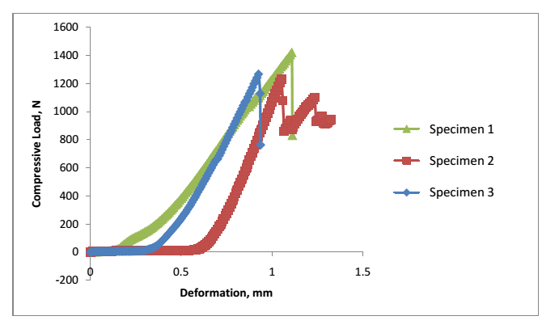

**Figure 7: Load-deformation curves for palm nut with average size 10 mm**

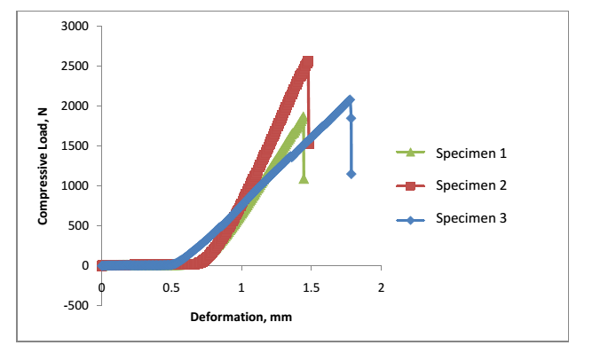

**Figure 8: Load-deformation curves for palm nut with average size 14 mm**

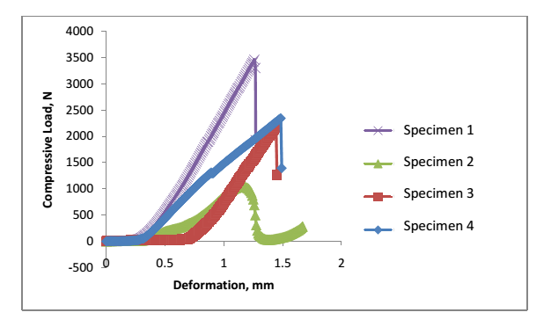

**Figure 9: Load-deformation curves for palm nut with average size 20 mm**

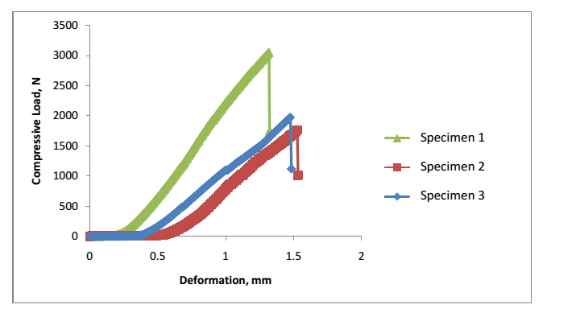

**Figure 10: Load-deformation curves for palm nut with average size 25 mm**

**3.2 Measured performance of the modified palm-nut cracker**

Figure11 is the output prototype showing the assembly of the fabricated modified palm nut cracker; while Table 3 shows the machine performance in terms of its cracking efficiency, mechanical damage and whole kernels. The results from the table at a glance apparently show that cracking efficiency and whole kernels increase with increasing nut sizes, and decrease at increase in the feed rates. The result also indicated that mechanical damage decreases as nut size increases but increases with increasing feed rate. Although the numerical deviations among the values obtained in this study may show no major significance prospectively, yet the output trend to some extent, confirms the findings of Ndukwu and Asoegwu (2010) that mechanical breakage increases with feed rate. In addition, it demonstrated that higher nut sizes favour lower mechanical damage, and that the lower the feed rate, the higher the cracking efficiency.

Moreover, Table 4 shows the cracking efficiencies and percentage kernel breakages from the modified machine at different operating conditions. An experiment had shown (Koya and Faborode, 2011) that 100% cracking efficiency was obtained in manual cracking; which appears reasonable, since all the nuts are cracked, though; some kernels (2.0%) are also broken in the process. The experimental mechanical nut cracking unit of the modified machine in the present study gave an average cracking efficiency of 92.35%, but 4.59 % of the kernels were broken when driven at 821 rpm. It appears this efficiency is lower than the 100% cracking efficiency obtained when the nutcracker was initially operated at the speed of 1410 rpm, which is within the speed range of existing nutcrackers. However, the result indicated that mechanical kernel breakage was reduced by about 53 %. This development has addressed to some extent, the limitation of the existing nutcrackers. The results therefore suggests that mechanical nutcracker will yield better performance in terms of cracking efficiency and whole kernel recovery, if it is operated at such reasonable lower speed.

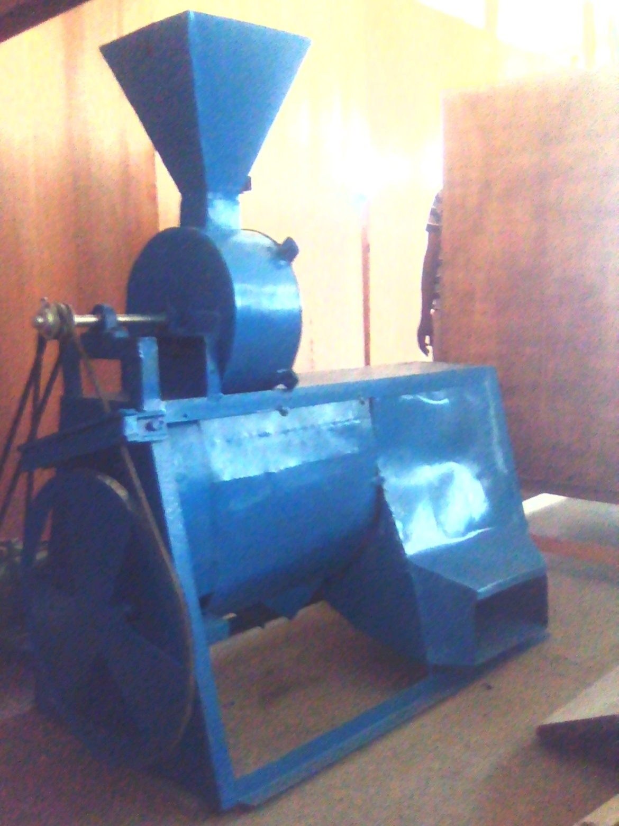

**12**

**4**

**6**

**5**

**19**

**2**

**7**

**11**

**10**

**9**

**8**

**3**

**Figure 11: Picture of the fabricated modified palm-nut cracker with pre-cleaner**

(1-feed hopper; 2-cracking chamber; 3-pre-cleaner cum classifier chamber; 4-small

kernel/shell outlet; 5-dirt outlet; 6-frame; 7-shaft; 8-cracking pulley; 9-belt; 10-pre-cleaner’s

pulley; 11-prime mover; 12-big kernel/shell outlet end)

**Table 3: Performance Indices Data for the Modified Palm Nut Cracker at**

**Moisture Content 13.4% w.b.**

|  |  |  |  |  |
| --- | --- | --- | --- | --- |
| Nut retained on sieve-size (mm) | Feed rate (Fr) kgh-1 | Mechanical damage (Md), % | Whole kernel (Mw), % | Cracking efficiency (CE), % |
| 10  14  20  25 | 85  90  95  85  90  95  85  90  95  85  90  95 | 5.02  5.03  5.15  5.01  5.10  5.15  4.09  4.10  4.14  4.03  4.10  4.12 | 94.98  94.97  94.85  94.99  94.90  94.85  95.91  95.90  95.86  95.97  95.90  95.88 | 96.80  92.25  86.10  96.85  92.50  87.20  97.15  93.10  87.85  97.27  93.11  88.00 |
|  |  |  |  |  |

**Table 4: Efficiencies of Palm Nut Cracking Operation of the Machine**

|  |
| --- |
| Speed (rpm) Mean efficiency (%) Mean kernel breakage (%) |

1410 100 (0.0) 9.83(0.4)

821 92.35 (0.4) 4.59 (0.5)

|  |
| --- |
| Numbers in parentheses are the standard deviations |

Data collected on the selected performance evaluation indices at different nut sizes and feed rates were further compared for statistical significance using one way Analysis of Variance (ANOVA) at 0.05 level for the samples. The results indicated that nut sizes have effect on mechanical damage and whole kernel recovered during experimentation. The nut sizes however showed no significant effect on the cracking efficiency of the modified machine developed and used for the present study. This shows the modified machine can effectively process palm nuts of all sizes with little or no effect of the later on it, which is an improvement over the existing nutcrackers. The ANOVA results further indicated that the selected feed rates for the study have no significant effects on mechanical damage and whole kernel recovery at 0.05 level. However, the varied feed rates shows significant effects on the values cracking efficiencies obtained. Hence, for enhanced cracking performance efficiency, it is suggested that mechanical nutcrackers are better operated at moderate feed rates.

**Conclusion**

Modified palm nut cracking machine which incorporated pre-cleaner and classifier with its members has been developed in this study. Palm-nut cracking at a moderately lower speed than the existing palm-nut crackers yielded satisfactory output in terms of quality based on the observed cracking efficiency, whole kernels recovered and obtained mechanical kernel damage.

The result from the study is therefore a significant step in enhancing subsequent product separation and the machine is adjudged suitable for small and medium scale application.

**References**

Adzimah, S. K. and Seckley, E. (2009). Modification in the design of an already

existing palm nut-fibre separator. *African Journal of Environmental Science and Technology*, 3(11): 387-398.

Akinoso, R., Raji, A. O. and Igbeka, J. C.(2009). Effects of compressive stress, feeding

rate and speed of rotation on palm kernel oil yield. *Journal of Food Engineering*, 93: 427- 430.

Akubuo, C. O. and Eje, B. E. (2002). Palm kernel and shell separator. *Biosystems*

*Engineering*,81(2): 193-199.

Alade, E. I. (2017). Performance Modelling of an Integrated Palm-Nut Cracker and Kernel-Shell

Separator. Unpublished Ph.D Thesis, Department of Mechanical Engineering, Obafemi Awolowo University, Ile – Ife, Nigeria.

Babatunde, O.O. and Okoli, J.O. (1988). Investigation into the effect of nut size on the

speed needed for cracking palm nut in centrifugal nut cracker. *Nigerian Journal of Palm and Oil Seeds*, 9(1): 84-88.

Badmus, G. A. (1990). Design of vertical shaft centrifugal palm nut cracker. Presented

to the Nigerian Society of Agriculture, University of Agriculture, Makurdi, Nigeria,pp. 24-48.

Ezeoha, S.L., Akubuo, C. O. and Ani, A.O.(2012).Proposed average values of some

engineering properties of palm kernel. *Nigerian Journal of Technology*. 31(2): 167-173.

Gbadam, E.K., Anthony, S. and Asiam, E.K. (2009). The determination of some

design parameters for palm nut crackers. *European Journal of Scientific Research*, 38 (2): 315-327.

Gbadamosi, L. (2006). Some engineering properties of palm kernel seeds. *Journal of*

*Agricultural Engineering and Technology*, 14: 58-67.

Hall, A.S., Holowenko, M.S., and Laughlin, G.H. (2004). *Shaum’s Outline of Theory*

*and Problems of Machine Design.* 4th Reprint, Tata McGraw-Hill Publishing Company Limited, USA, pp. 113-115.

Hartley, C.W.S. (1977).*The Oil Palm*. Longman Publishers, London,pp. 1-134, 432-

443.

Ilechie, C.O. (1985). NIFOR 22nd annual report. *Journal of Nigerian Institute for Oil*

*Palm Research*, Benin City, Nigeria: 92- 94.

Jimoh, M.O. and Olukunle, O.J. (2012).Effect of heat treatment during mechanical

cracking using varieties of palm nut. *Agricultural Engineering International:*

*CIGR Journal*. 14(3): 168-174.

Jimoh, M.O. and Olukunle, O.J. (2013). Effect of physico-mechanical properties of

palm nut on machine performance evaluation. *World Applied Programming*, 3(7): 2-7.

John, H. and Stephens, R. C. (1999).*Mechanics of Machines, Advanced Theory and*

*Examples*. 2nd edition, Published for Viva Books Private Limited, New Delhi, pp. 1-2.

Kayode, O. and Koya, O.A. (2012). Some physical and mechanical properties of palm

nut and coconut shells related to size reduction processes. *Ife Journal of Technology*, 21(1): 1-4.

Khurmi, R. S. and Gupta, J. K. (2005). *A Textbook of Machine Design*.14th edition,

S.Chand and Company Limited, New Delhi, (Chapter 9).

Koya, O.A., Idowu, A. and Faborode, M.O. (2004). Physical properties of palm kernel

and shell relevant in nut cracking and product separation. *Journal of Agricultural Engineering and Technology*, 12: 27–39.

Koya, O.A. (2006). Palm nut cracking under repeated impact load. *Journal of*

*Applied Sciences,* 6(11): 2471-2475.

Koya, O.A. and Faborode, M.O. (2005). Mathematical modelling of palm nut

cracking based on hertz’s theory. *Biosystems Engineering,* 91(4): 471-478.

Koya, O.A. and Faborode, M.O. (2011). Influence of nut cracking methods on kernel

quality and separability of product. *Ife Journal of Technology*, 20 (1):54-57.

Manuwa, S.I. (1997). Design, fabrication and testing of a low cost palm nut cracker.

Proceedings of the 19thAnnual Conference of the Nigerian Society of Agricultural Engineers, Federal University of Technology, Owerri, Nigeria, 2-6th September, 1997.

Manuwa, S.I. (1998). Fracture resistance of palm nuts to compressive loading.

Proceedings of the20thAnnual Conference of the Nigeria Society of Agricultural Engineering, at Lagos Airport Hotel, Lagos, Nigeria, 9-12th September, 1998.

Ndukwu, M.C. and Asoegwu, S.N. (2010). Functional performance of a vertical-shaft

centrifugal palm nut cracker. *Research in Agricultural Engineering*, 56: 77-83.

Obiakor, S.I. and Babatunde, O.O. (1999). Development and testing of the NCAM

centrifugal palm nut cracker. AGRIMECH Research and Information Bulletin of the National Centre for Agricultural Mechanization (NCAM), January, 1999.

Ofei, T. N. (2007). Design of Palm Nut Cracker: Influence of Drying Time on Static

Force Required to Crack Nut. Unpublished B.Sc. Project, University of Mines and Technology, Tarkwa, Ghana, pp.37.

Ogunsina, B.S., Koya, O.A and Adeosun, O.O. (2008). Deformation and fracture of

ndika nut under uni-axial compressive load. *International Agrophysics*, 22: 249-253.

Okoli, J.U.(1997). Determination of optimum hurling speed for effective palm nut

cracking. Harrison Publishing Company, Port Harcourt, Rivers State, Nigeria.

Olakanmi, E.O. (2004). Development and performance testing of a palm kernel

Proceedings of 19th Annual Conference of the Nigerian Society of Agricultural Engineers, Federal University of Technology, Owerri, Nigeria. Cracker. Compendium of Engineering Monograghs. 1:1-3.

Olukunle O. J., Jimoh, M. O. and Atere, A.O. (2008). Development and performance

evaluation of a motorized nut cracker. *International Journal of Engineering and Engineering Technology*, 6(1): 45-55.

PSG Tech. (1982). Design Data Compiled by Faculty of Mechanical Engineering, PSG

College of Technology, Combatoire, India.

Wang, C., Zhang, L., and Mai, Y. (1995). Deformation and fracture of macadamia

nuts-part 2: Deformation analysis of nut-in-shell. *International Journal of*

*fracture*, 69: 51-65.